

**Project Report**

**On**

**E-Healthcare Management System**

Submitted By

MOKSH TENG

1911985066

# **ACKNOWLEDGEMENT**

We take this occasion to thank God, almighty for blessing us with his grace and taking our endeavour to a successful culmination. We extend our sincere and heartfelt thanks to our esteemed guides, Mr. Mukesh Sirand Mr. Mananjay Sir, for providing us with the right guidance and advice at the crucial junctures and for showing me the right way. I am overwhelmed in all humbleness and gratefulness to acknowledge my depth to all those who have helped me to put these ideas, well above the level of simplicity and into something concrete.

**PURPOSE**

The e-Healthcare management system is a web-based project that seeks to provide effective management of employee data and medical data of patients in hospitals and clinics. It consists of 3 modules: an administration module, doctor module and patient module. While the administration module is concerned with medicare management that includes doctors and appointments. The doctor module is concerned with appointments and creating medical records for patients. The patient module is for clients concerned with booking appointments.

**Module Description:**

It’s an online Health Care Management service which is named Zencare. It’s convenient, it gives you the widest choice possible and it can be done sitting in the privacy of one’s cubicle. Today when professionals across the world are spending 10-12 hours at work every day, Online Health Care Management reduces the time and complexity.

# Number of Modules

The system after careful analysis has been identified to be presented with the following modules:

**The modules involved are:**

* ADMIN MODULE
* DOCTOR MODULE
* PATIENT MODULE

**Module Description:**

It has mainly divided into three modules

**1. ADMIN MODULE**

In this module admin maintains the Patient records and Doctors schedule and only has the permission to delete or modify the patient; create, invalidate the doctors and create or delete other admins records. He/She can accept, decline or confirm appointments booked by patients.

**2. DOCTOR MODULE**

This will hold the details of the patient problem & the related doctors who have taken care of particular patients. He/She has to follow the schedules given by the administration. He/She can accept, decline or confirm appointments booked by patients. He/She can create electronic medical records for patients.

**3. PATIENT MODULE**

Consultation holds the details of the patient’s history. Details of medication details & the details of the diet / exercise the patients have to follow. This gives the records in detail of patient medical history visit wise. This helps to easily go through the patients’ medical history.Inthis module a user can register and edit his/her profiles and can book new appointments.

**Technologies Used:**

Various web development technologies are used to create Zencare. These are:

**Front-end technologies:** HTML, CSS, JS, React JS, Axios, Yup, React Router, Bootstrap.

* HTML: (HyperText Markup Language) is the most basic building block of the Web. It defines the meaning and structure of web content. HTML is the standard markup language for Web pages. With HTML we can create our own Website.
* CSS: Cascading Style Sheets (CSS) is astylesheet language used to describe the presentation of a document written inHTML or XML. CSS describes how elements should be rendered on screen, on paper, in speech, or on other media.
* JS: It is a lightweight, interpreted programming language. It is designed for creating network-centric applications. JavaScript is very easy to implement because it is integrated with HTML. It is open and cross-platform. JavaScript can be used forclient-side developments as well asserver-side developments. It is used to make webpages interactive (e.g., having complex animations, clickable buttons, popup menus, etc.
* React JS: It is a JavaScript library that combines the speed of JavaScript and uses a new way of rendering web pages, making them highly dynamic and responsive to user input. aces. React is not a framework – it's not even exclusive to the web. It's used with other libraries to render to certain environments. React's primary goal is to minimise the bugs that occur when developers are building UIs. It does this through the use of components — self-contained, logical pieces of code that describe a portion of the user interface. These components can be composed together to create a full UI, and React abstracts away much of the rendering work, leaving you to concentrate on the UI design.
* Axios: It is a javascript used to make HTTP requests to the server to perform certain actions. These requests are promise based and use the concept of asynchronous javascript.
* Yup: It is a js library used to perform JS object validation.
* React Router: Itis a standard library for routing in React. It enables the navigation among views of various components in a React Application, allows changing the browser URL, and keeps the UI in sync with the URL.
* Bootstrap: It is afree and open-source CSS framework directed at responsive, mobile-first front-end web development. It contains HTML, CSS and (optionally) JavaScript-based design templates for typography, forms, buttons, navigation, and other interface components.

**Backend technologies:** Java, Spring Boot, Spring Core, Spring Security(with JWT), Hibernate, Spring Boot JPA, MySQL, Spring Boot Starter Validation, Spring Boot Starter Mail.

* Java: It is a programming language and a platform. Java is a high level, robust, object-oriented and secure programming language. It is used to develop mobile apps, web apps, desktop apps, games and much more.
* Spring Boot: It is a project that is built on the top of the Spring Framework. It provides an easier and faster way to set up, configure, and run both simple and web-based applications. It is a Spring module that provides the RAD (*Rapid Application Development*) feature to the Spring Framework. It is used to create a stand-alone Spring-based application that you can just run because it needs minimal Spring configuration. In short, Spring Boot is the combination of Spring Framework and Embedded Servers.
* Spring Core: It is the core of the framework that powers features such as Inversion of Control and dependency injection. Spring framework is an open source Java platform that provides comprehensive infrastructure support for developing robust Java applications very easily and very rapidly.
* Spring Security: It is a framework which provides various security features like: authentication, authorization to create secure Java Enterprise Applications. Spring Security is a powerful and highly customizable authentication and access-control framework. It is the de-facto standard for securing Spring-based applications. It is a framework that focuses on providing both authentication and authorization to Java applications. Like all Spring projects, the real power of Spring Security is found in how easily it can be extended to meet custom requirements
* MySQL Driver: It provides standards-based drivers for JDBC, ODBC, and .Net enabling developers to build database applications in their language of choice. In addition, a native C library allows developers to embed MySQL directly into their applications.
* Hibernate: It is an object-relational mapping solution for Java environments. Object-relational mapping or ORM is the programming technique to map application domain model objects to the relational database tables. Hibernate is a Java-based ORM tool that provides a framework for mapping application domain objects to the relational database tables and vice versa.
* Spring Boot JPA: It is a Java specification for managing relational data in Java applications. It allows us to access and persist data between Java objects/ class and relational databases. JPA follows Object-Relational Mapping (ORM). It is a set of interfaces. It also provides a runtime EntityManager API for processing queries and transactions on the objects against the database. It uses a platform-independent object-oriented query language JPQL (Java Persistence Query Language).
* Spring Boot Starter Validation: It performs beans validation by applying certain constraints on it.
* Spring Boot Starter Mail: The Spring Framework provides an easy abstraction for sending email by using the JavaMailSender interface, and Spring Boot provides auto-configuration for it as well as a starter module.
* JWT: JSON Web Token or JWT, as it is more commonly called, is an open Internet standard (RFC 7519) for securely transmitting trusted information between parties in a compact way. The tokens contain claims that are encoded as a JSON object and are digitally signed using a private secret or a public key/private key pair. They are self-contained and verifiable as they are digitally signed. JWT’s can be signed and/or encrypted. The signed tokens verify the integrity of the claims contained in the token, while the encrypted ones hide the claims from other parties.
* MySQL: It is a relational database management system (RDBMS) that is based on structured query language (SQL).A database is a structured collection of data. It may be anything from a simple shopping list to a picture gallery or a place to hold vast amounts of information in a corporate network. In particular, a relational database is a digital store collecting data and organising it according to the relational model. In this model, tables consist of rows and columns, and relationships between data elements all follow a strict logical structure. An RDBMS is simply the set of software tools used to actually implement, manage, and query such a database.

**UML Diagrams:**

**ER Diagram:**

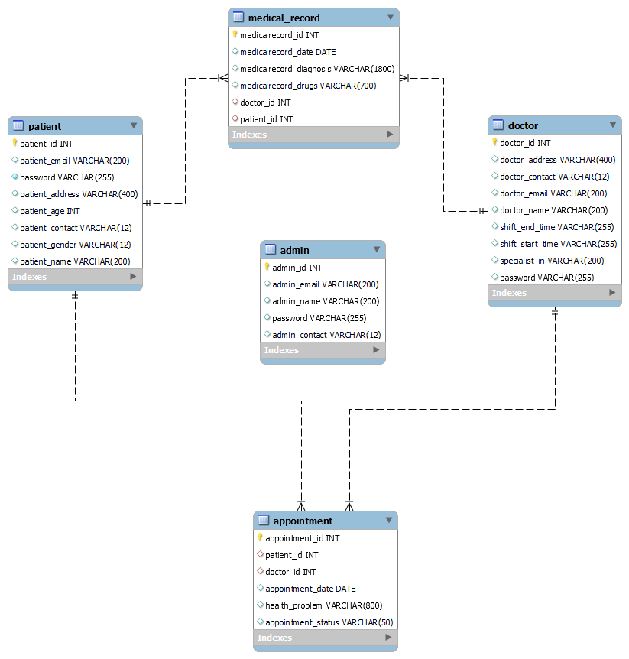

**Data Flow Diagram:**

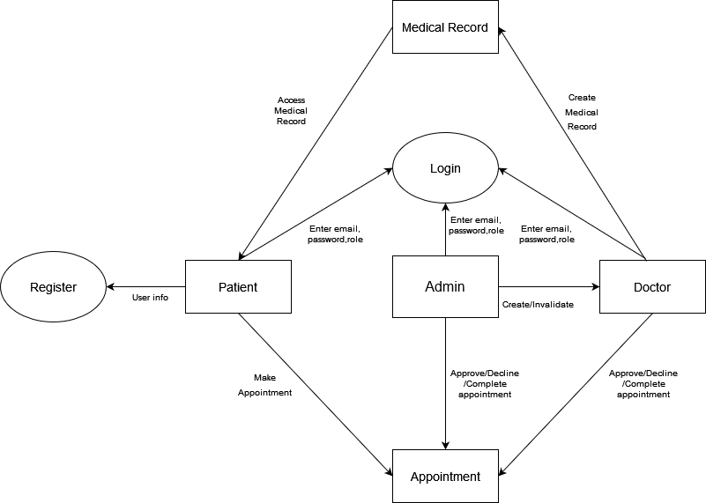

**Class Diagrams:**

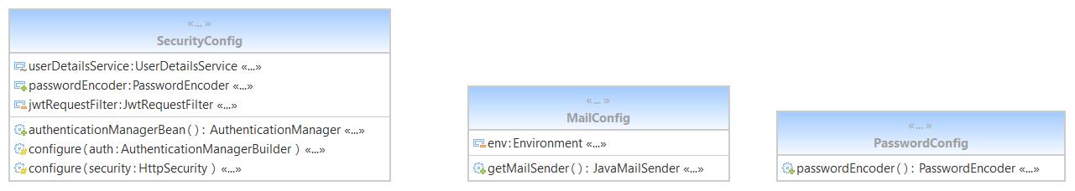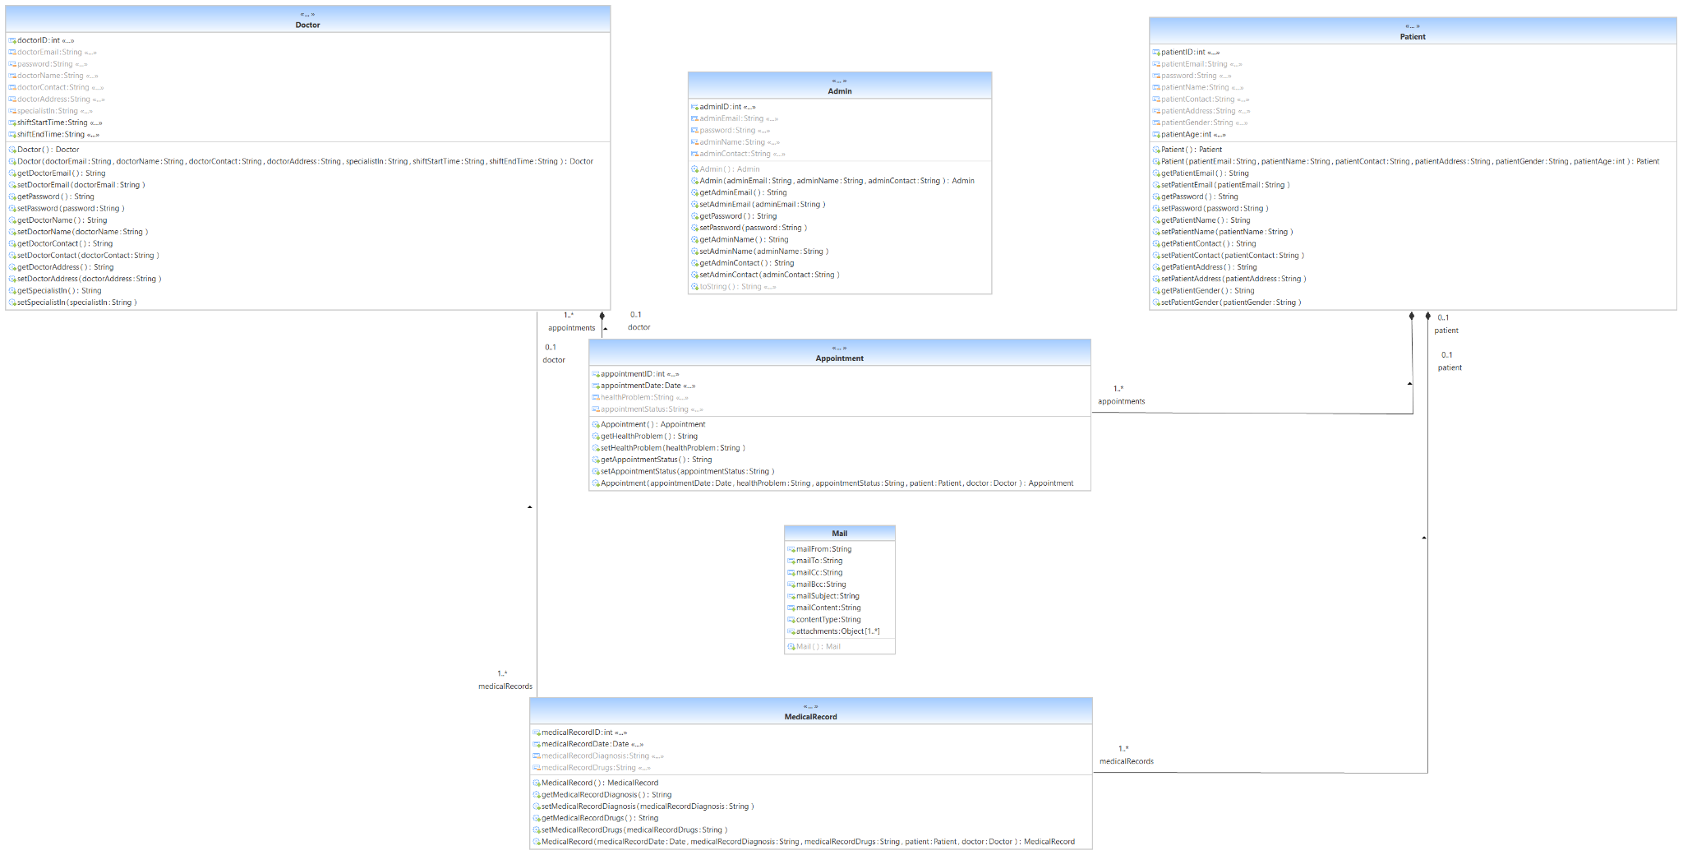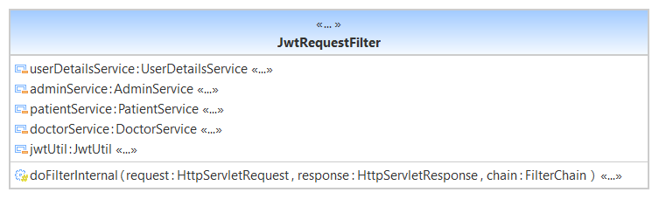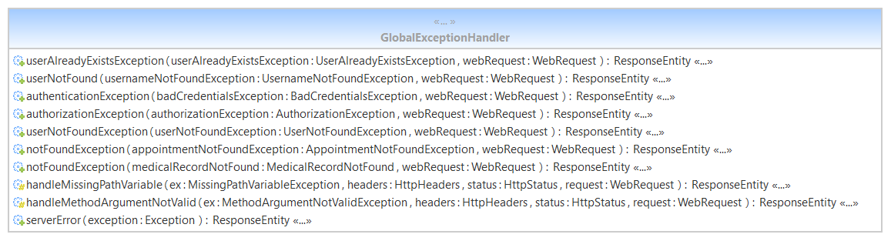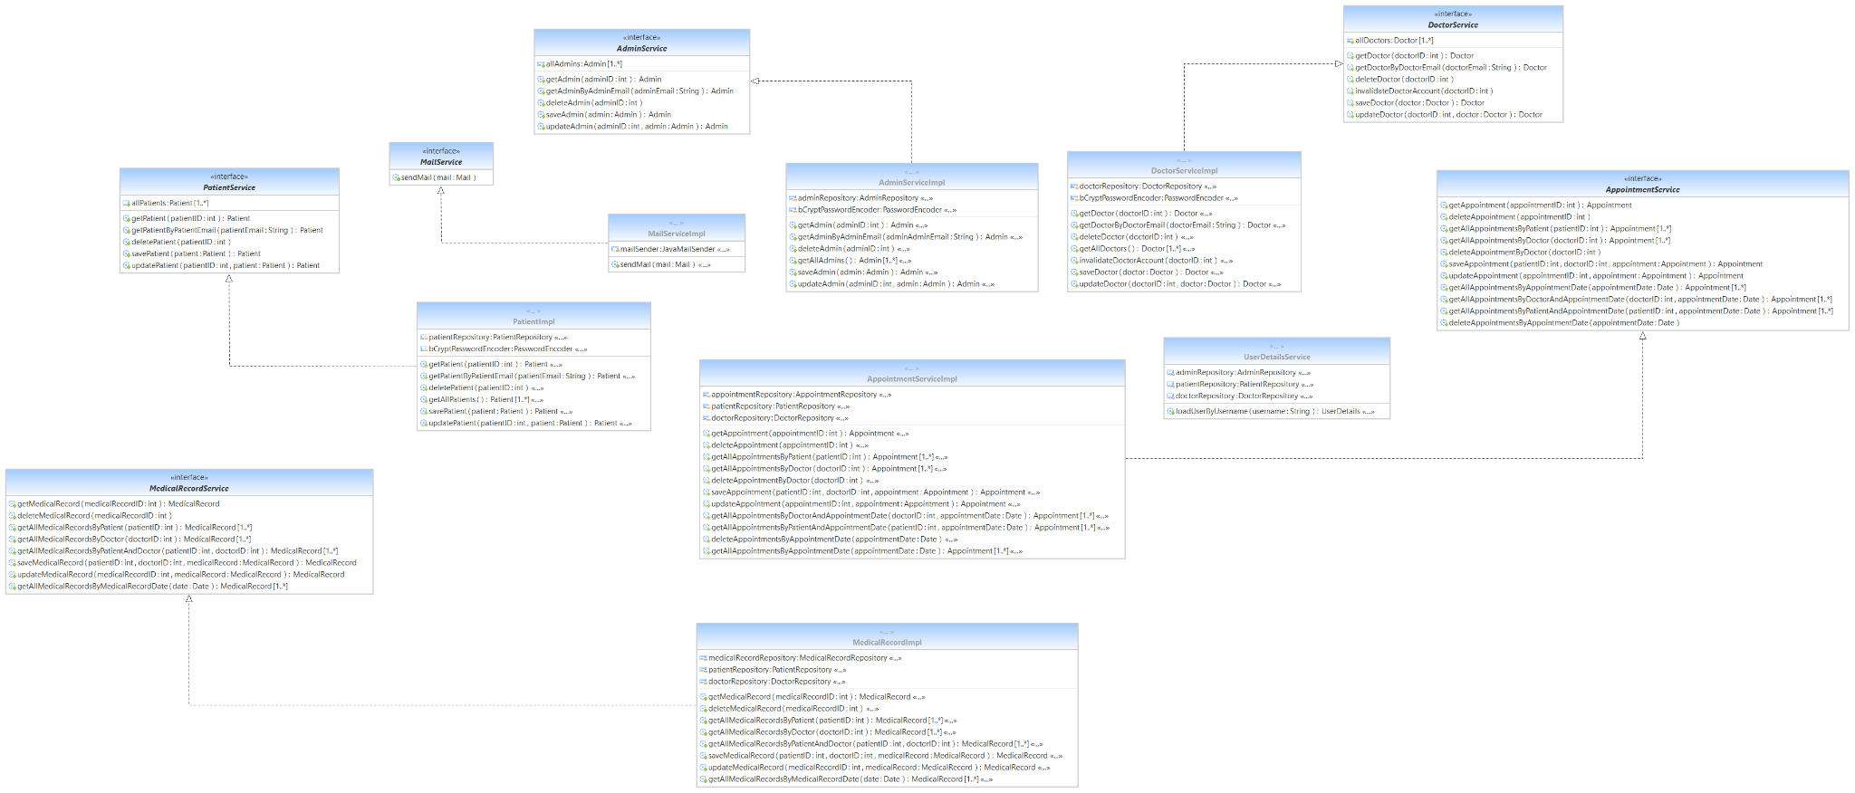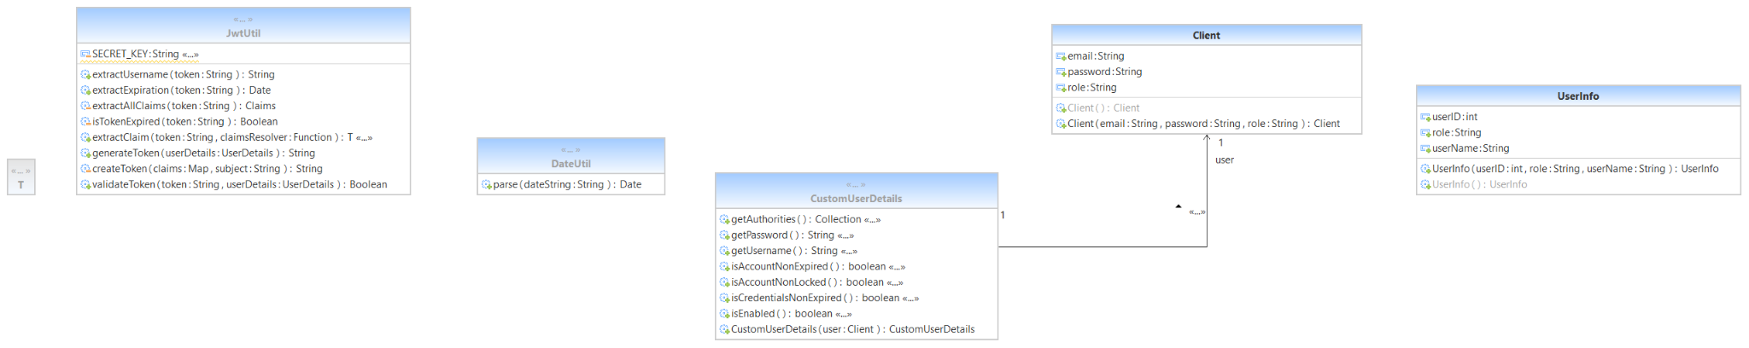

**Screenshots:**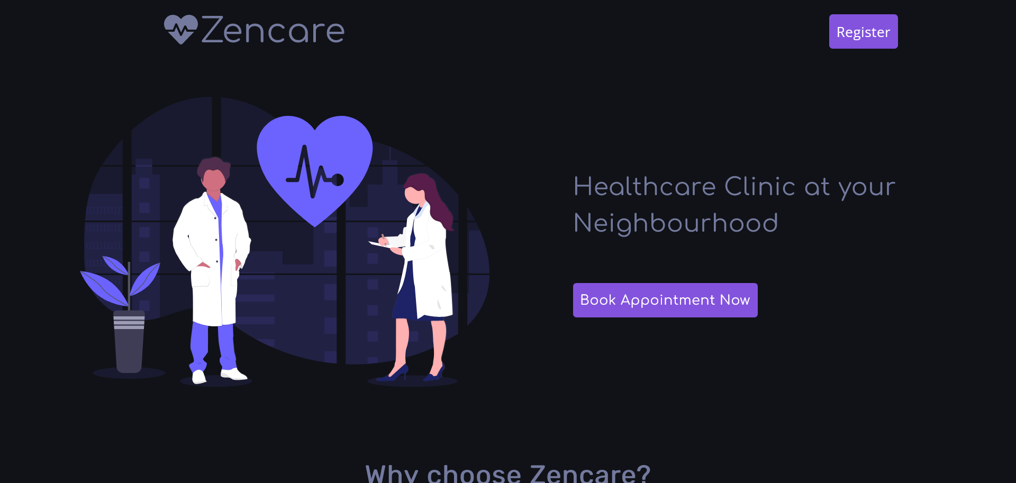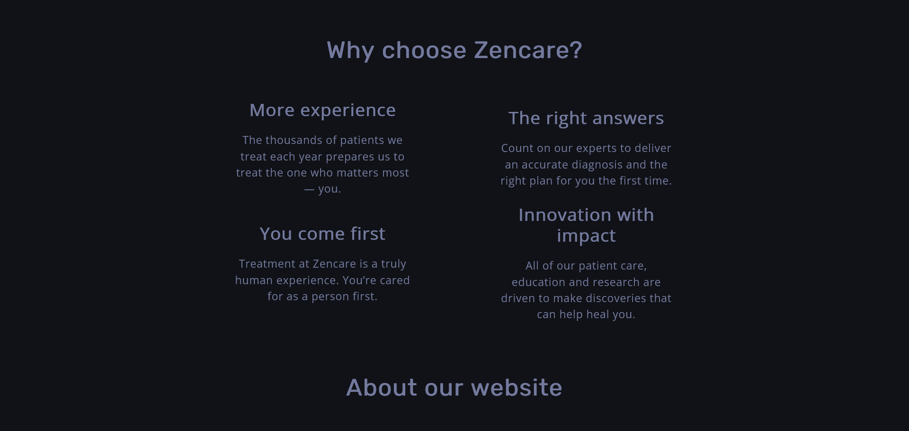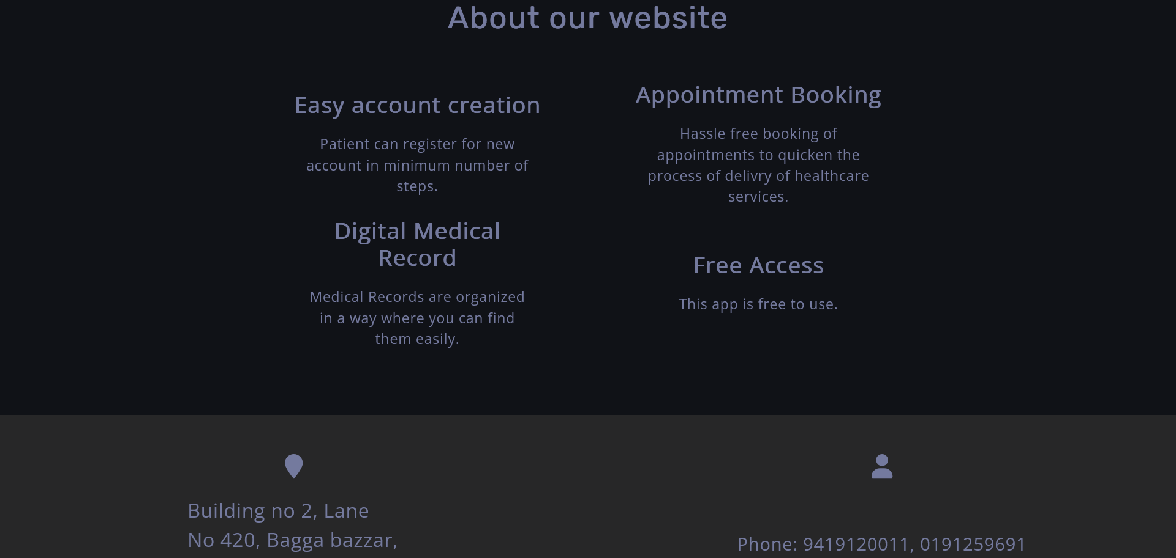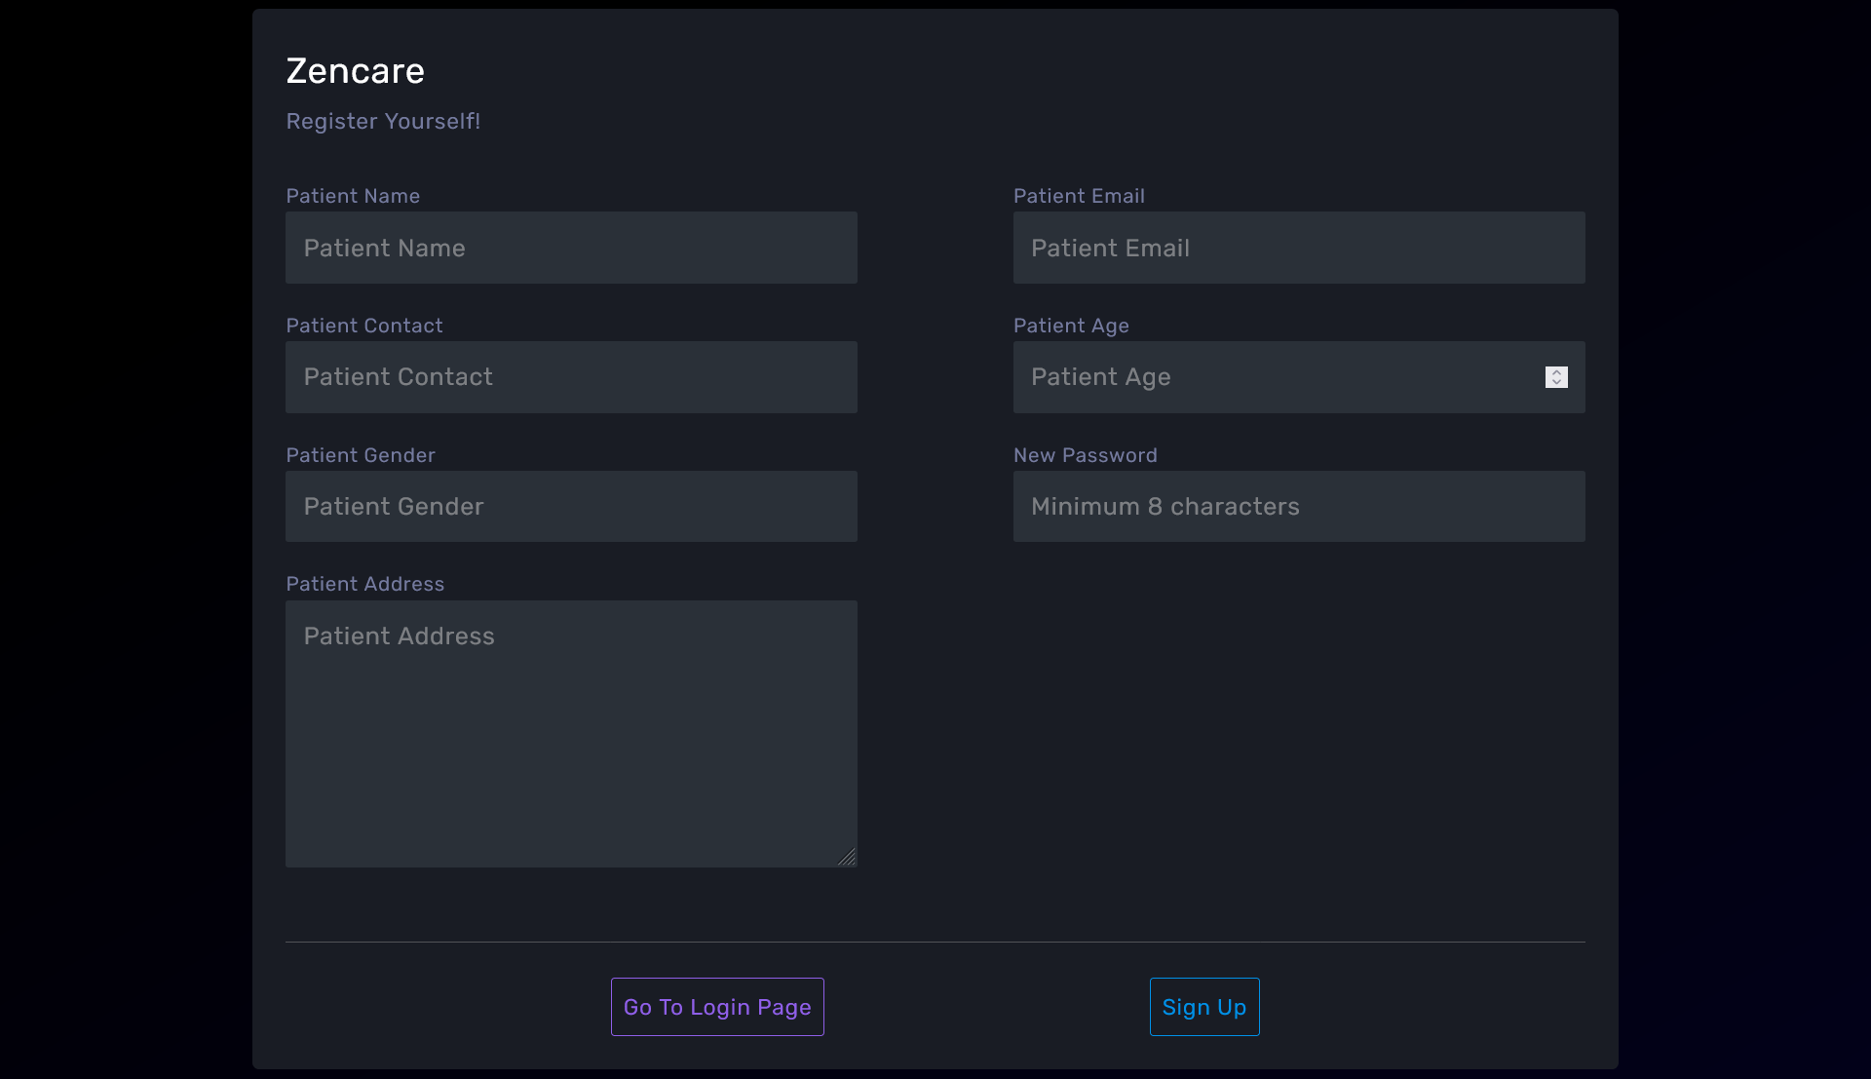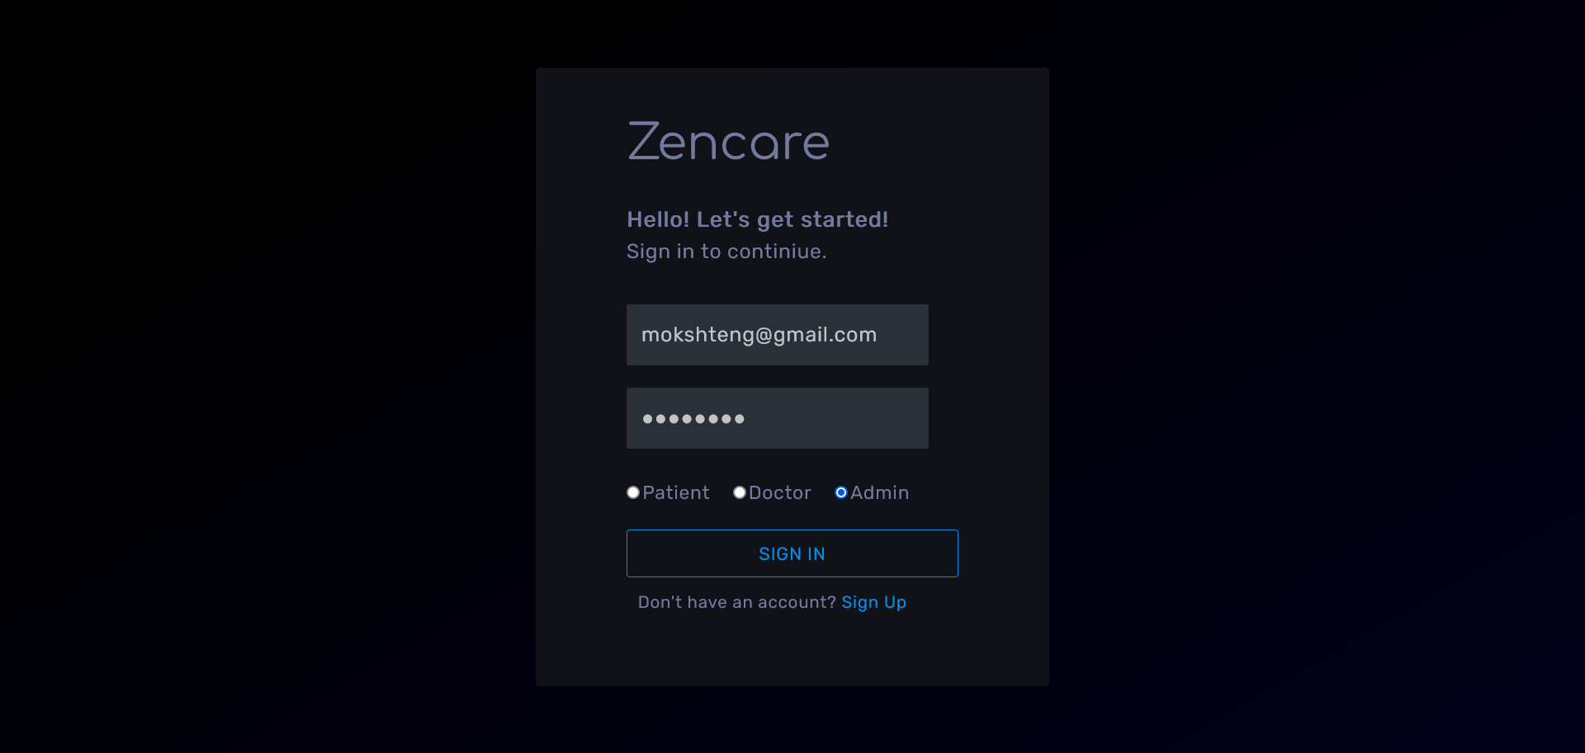

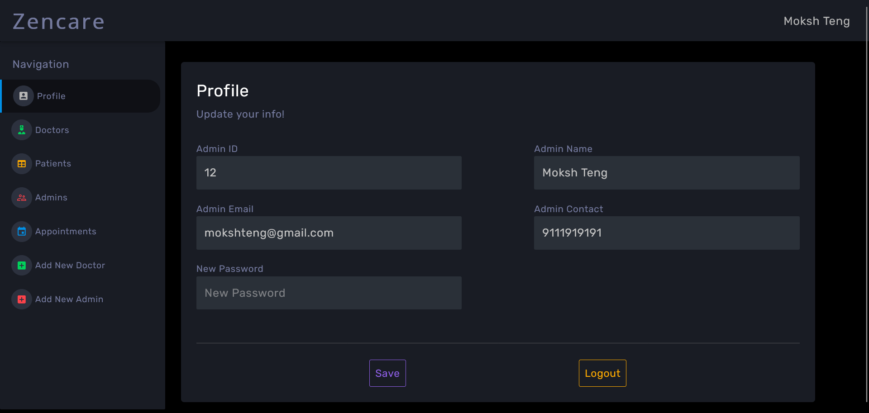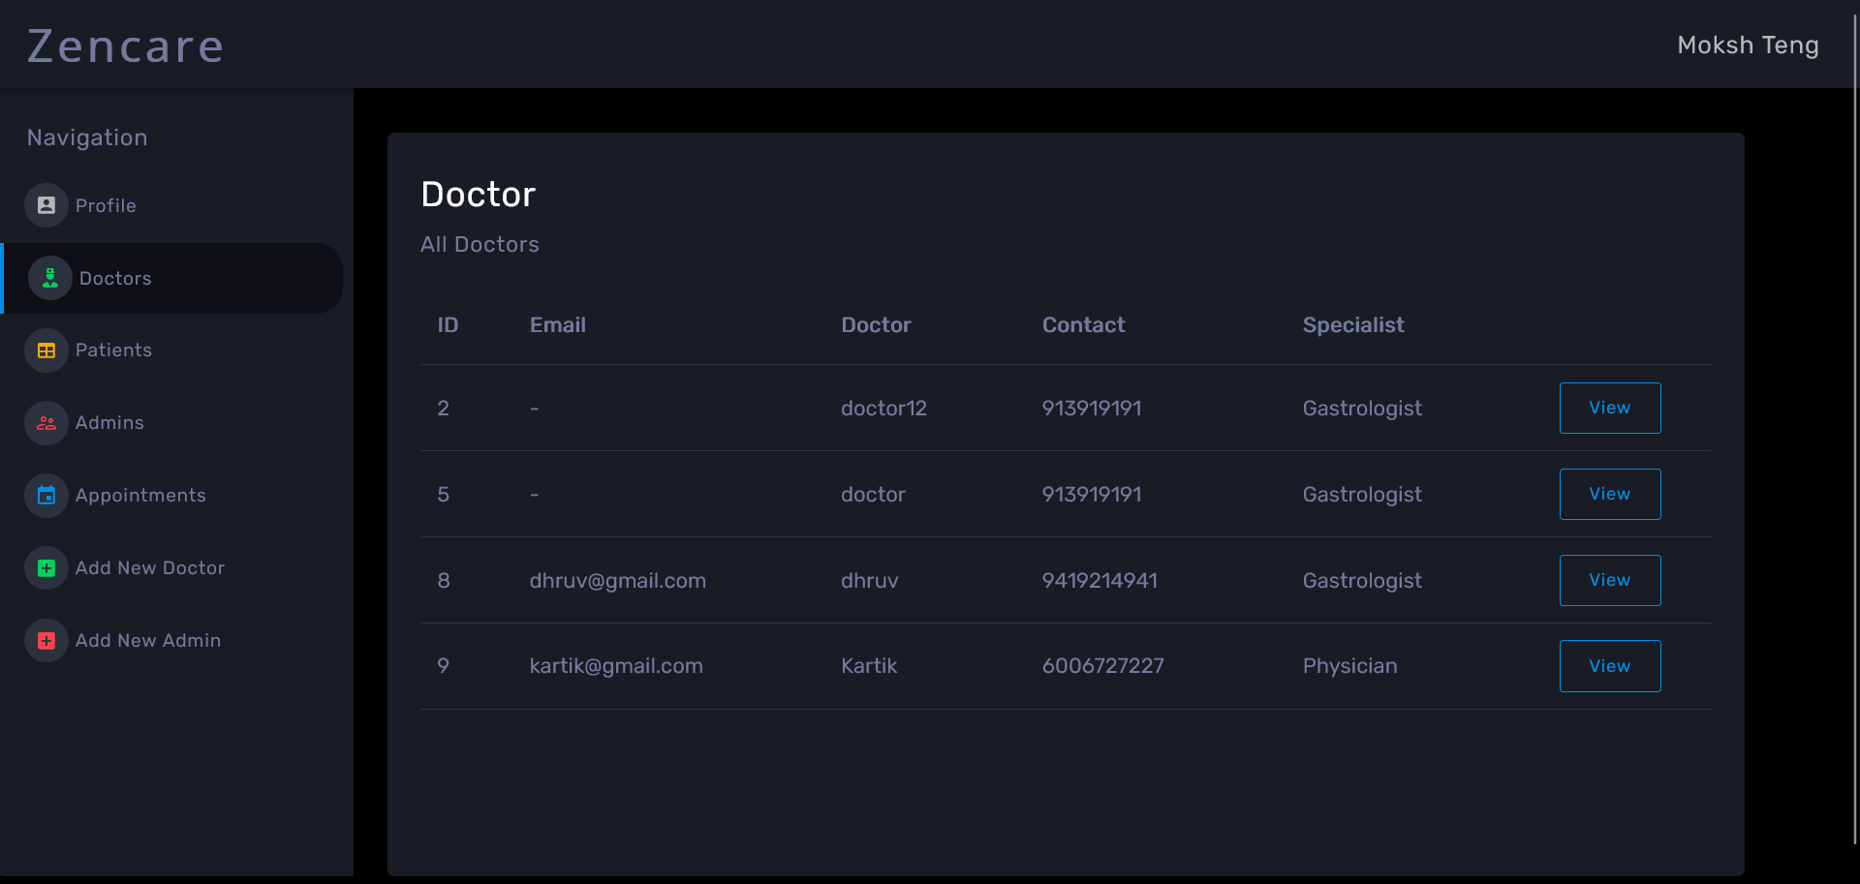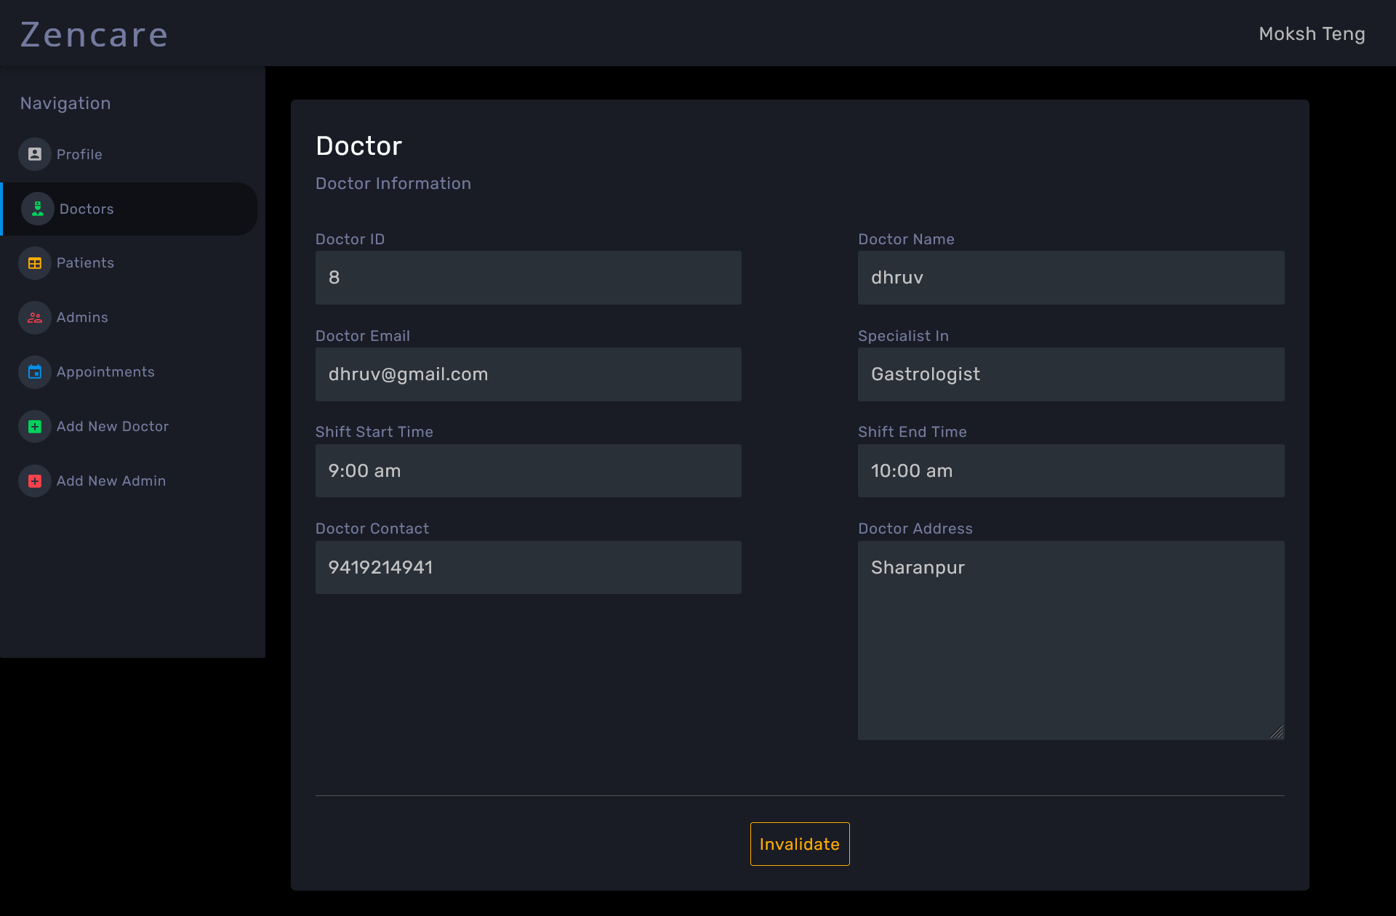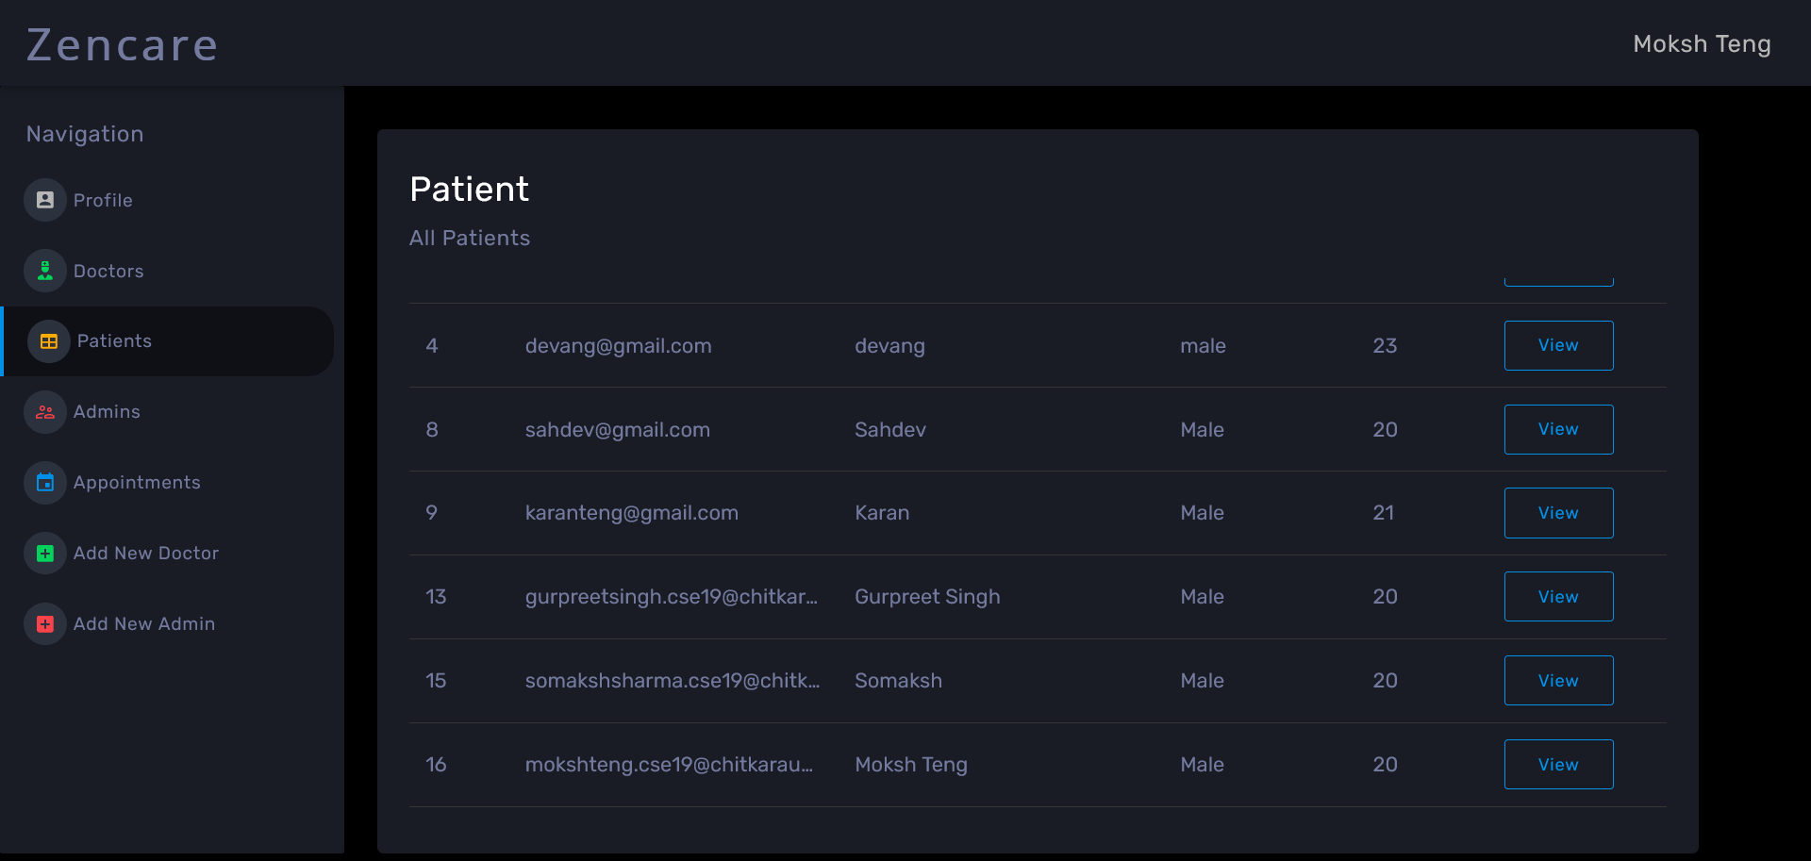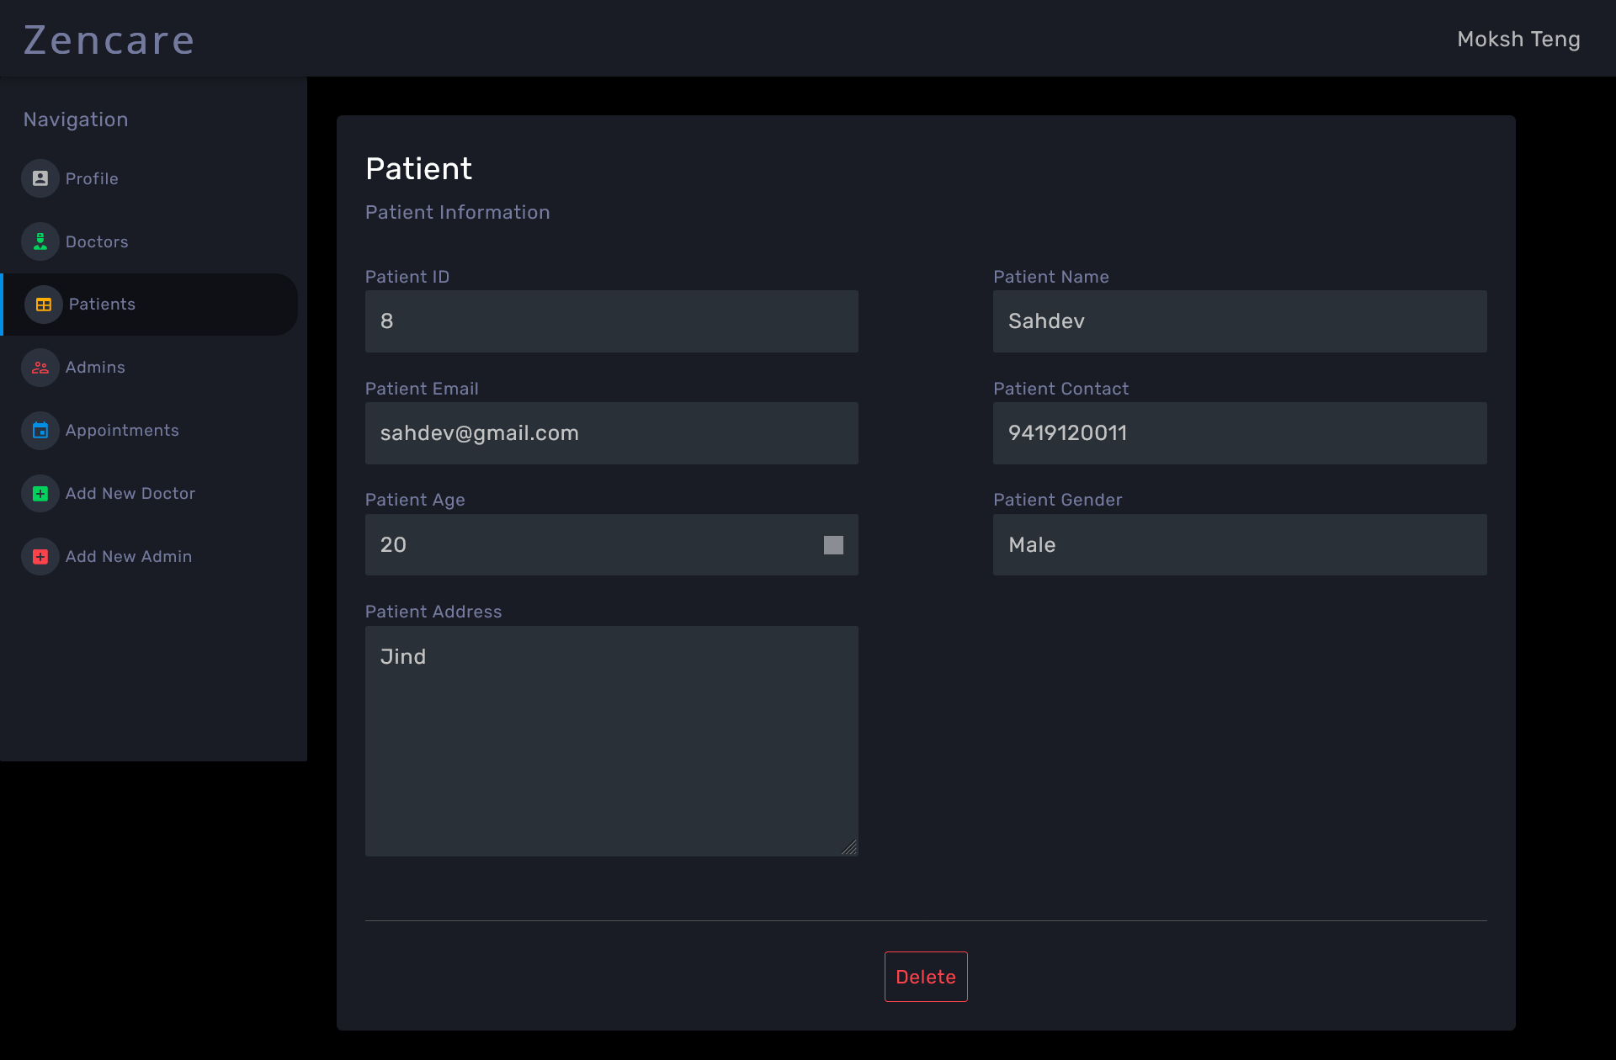

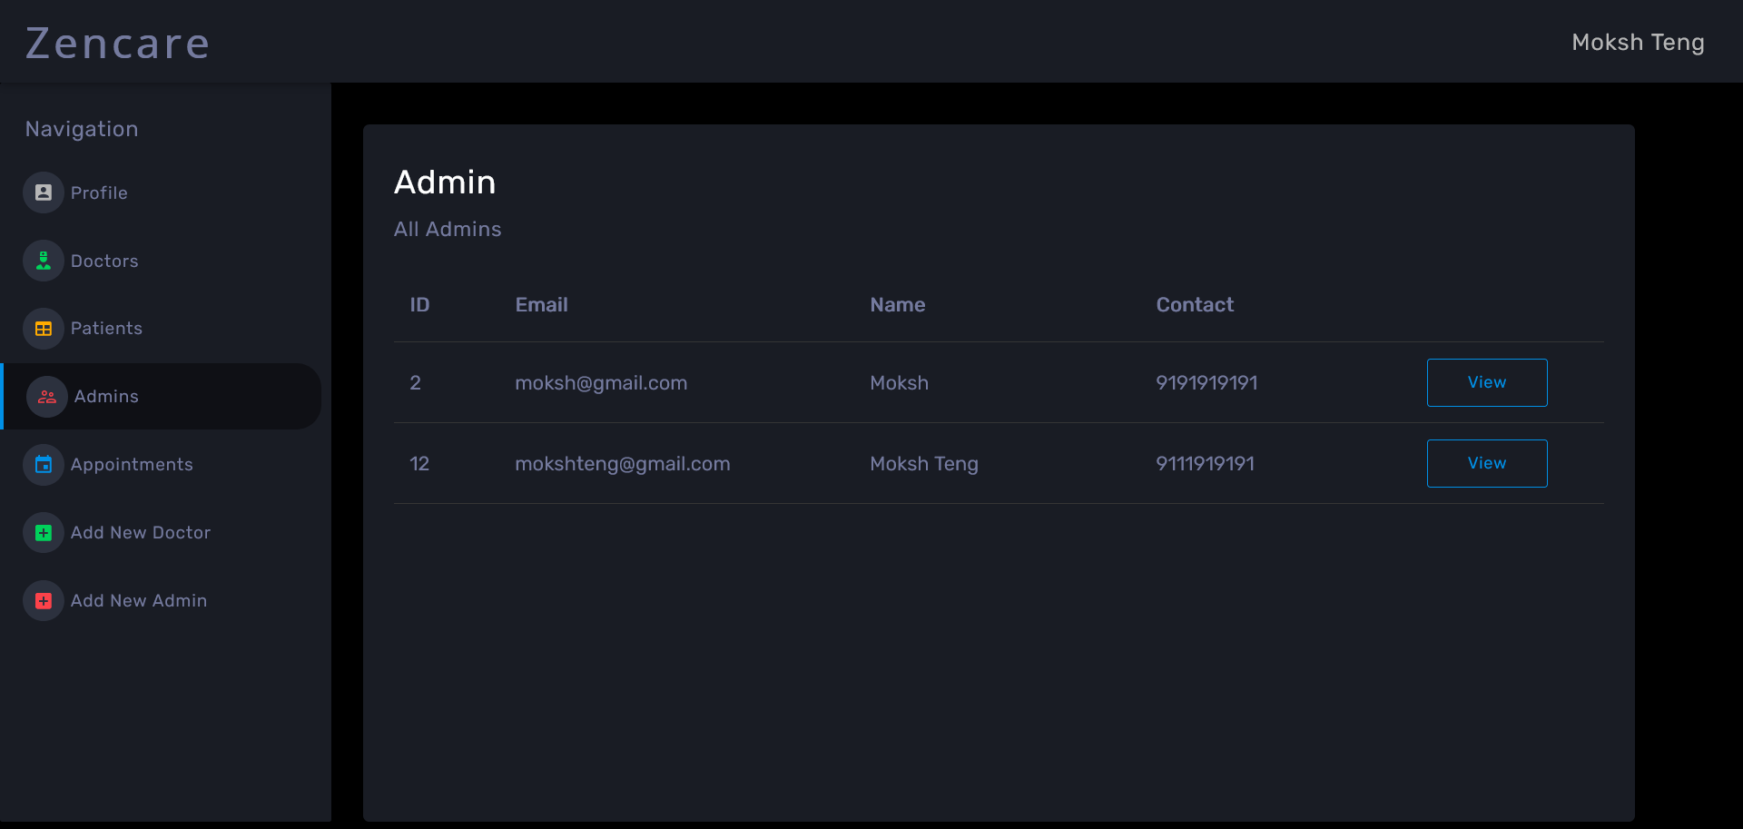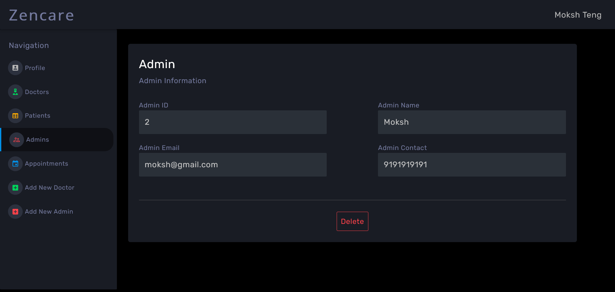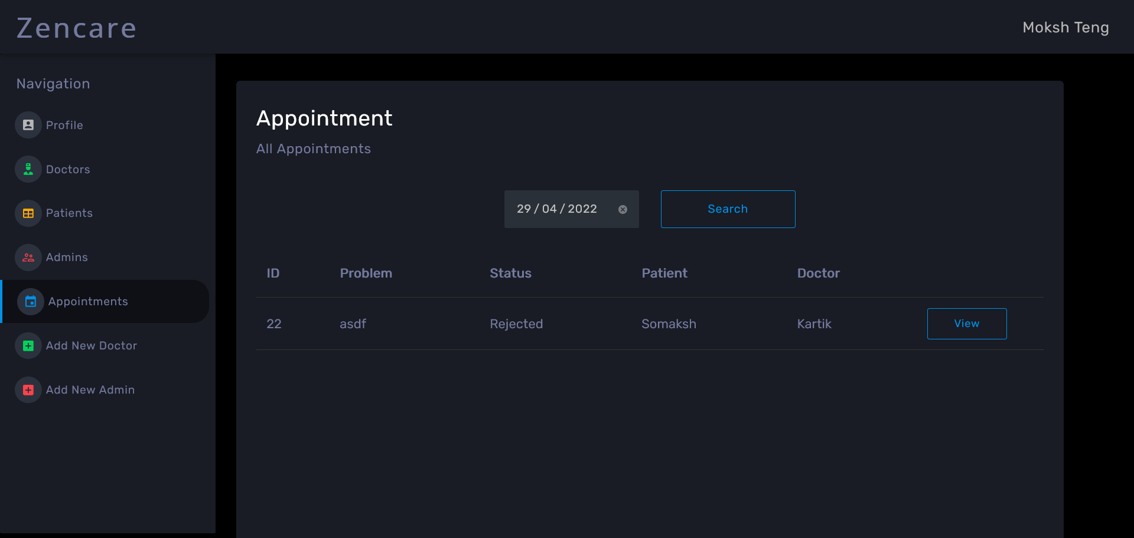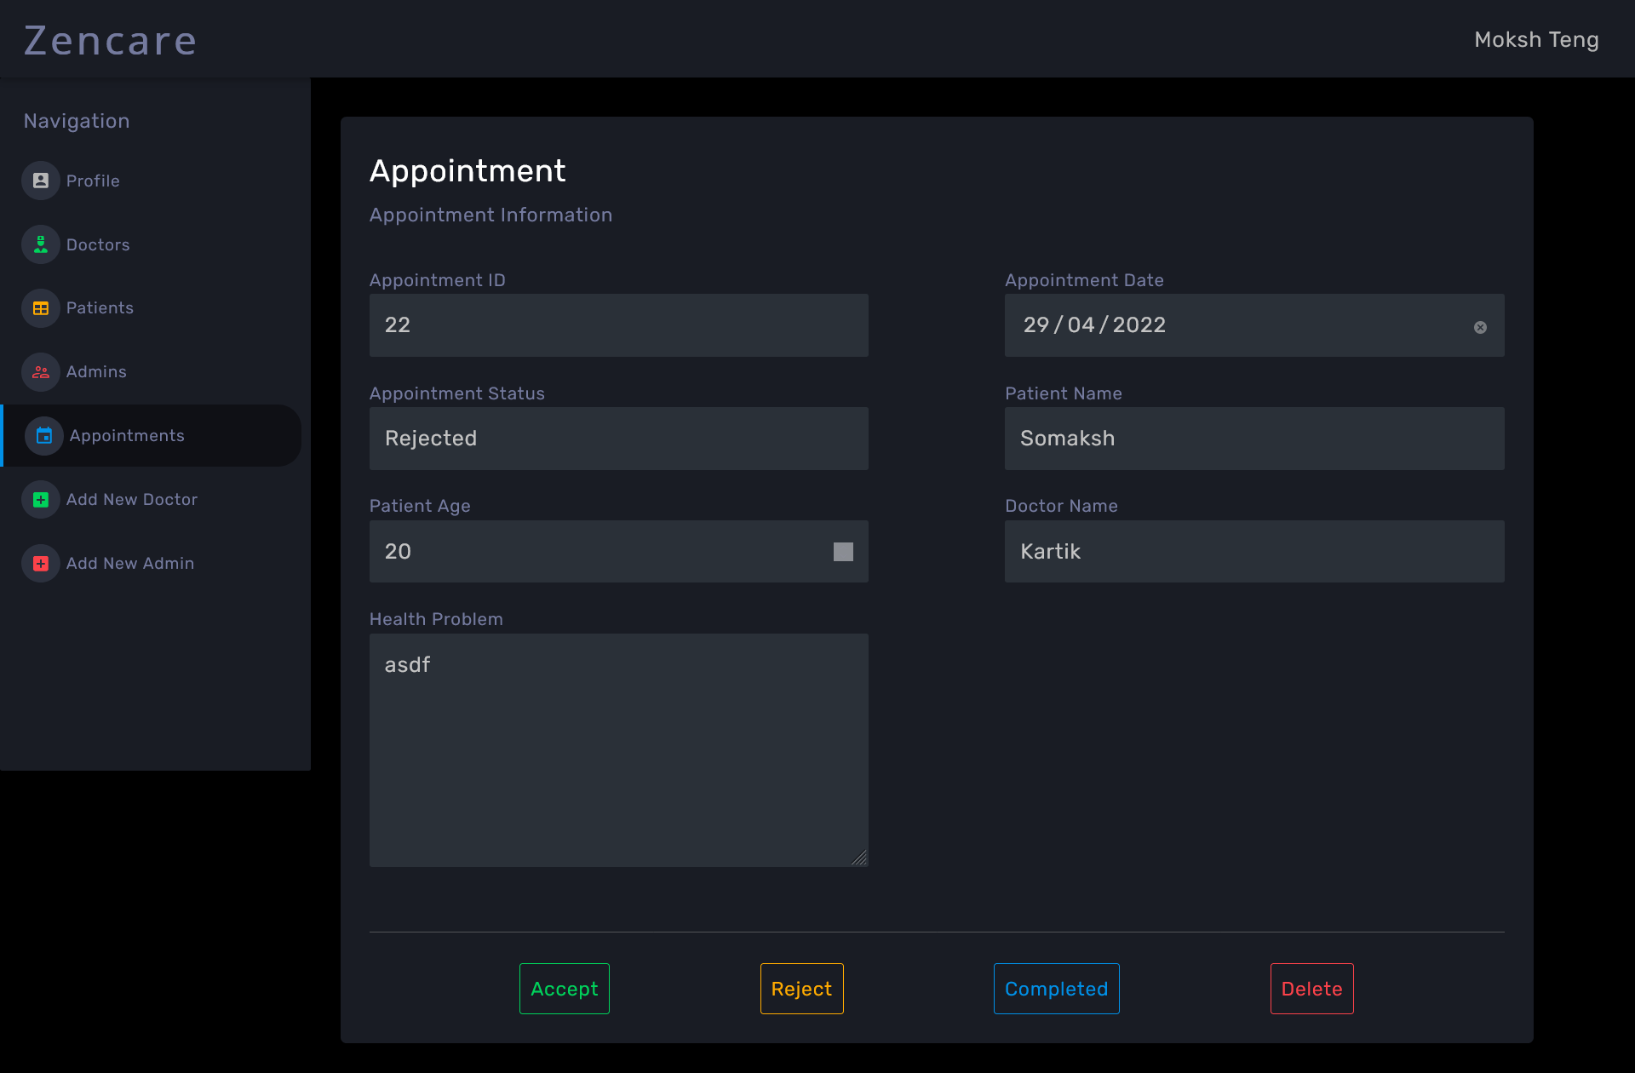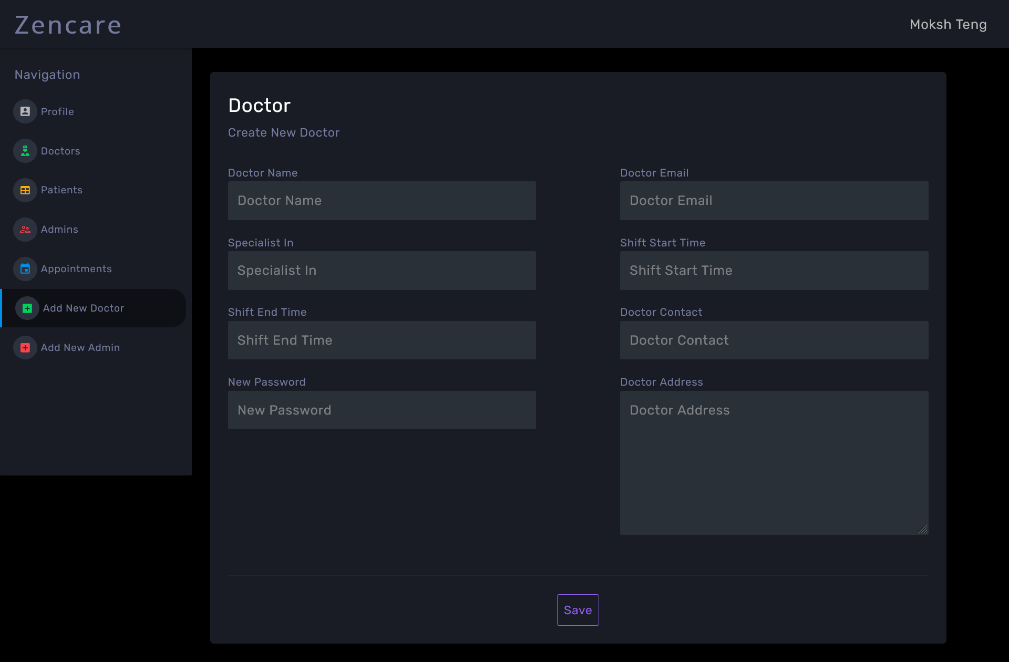

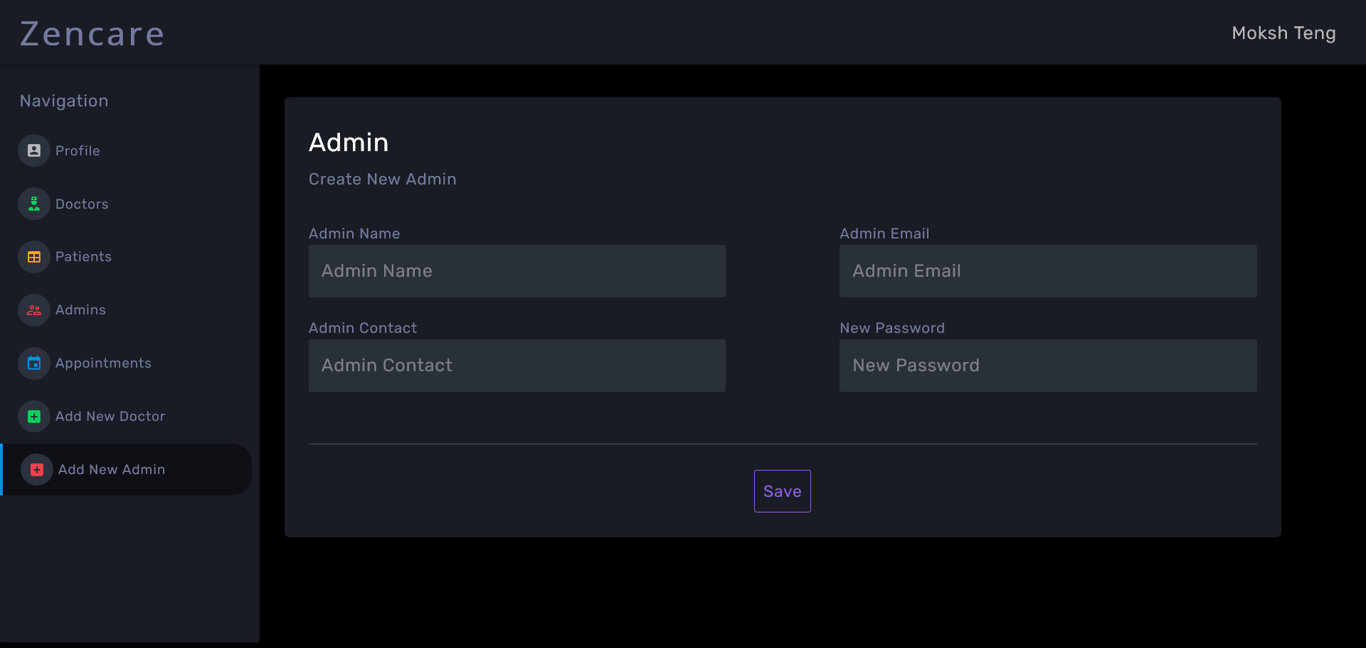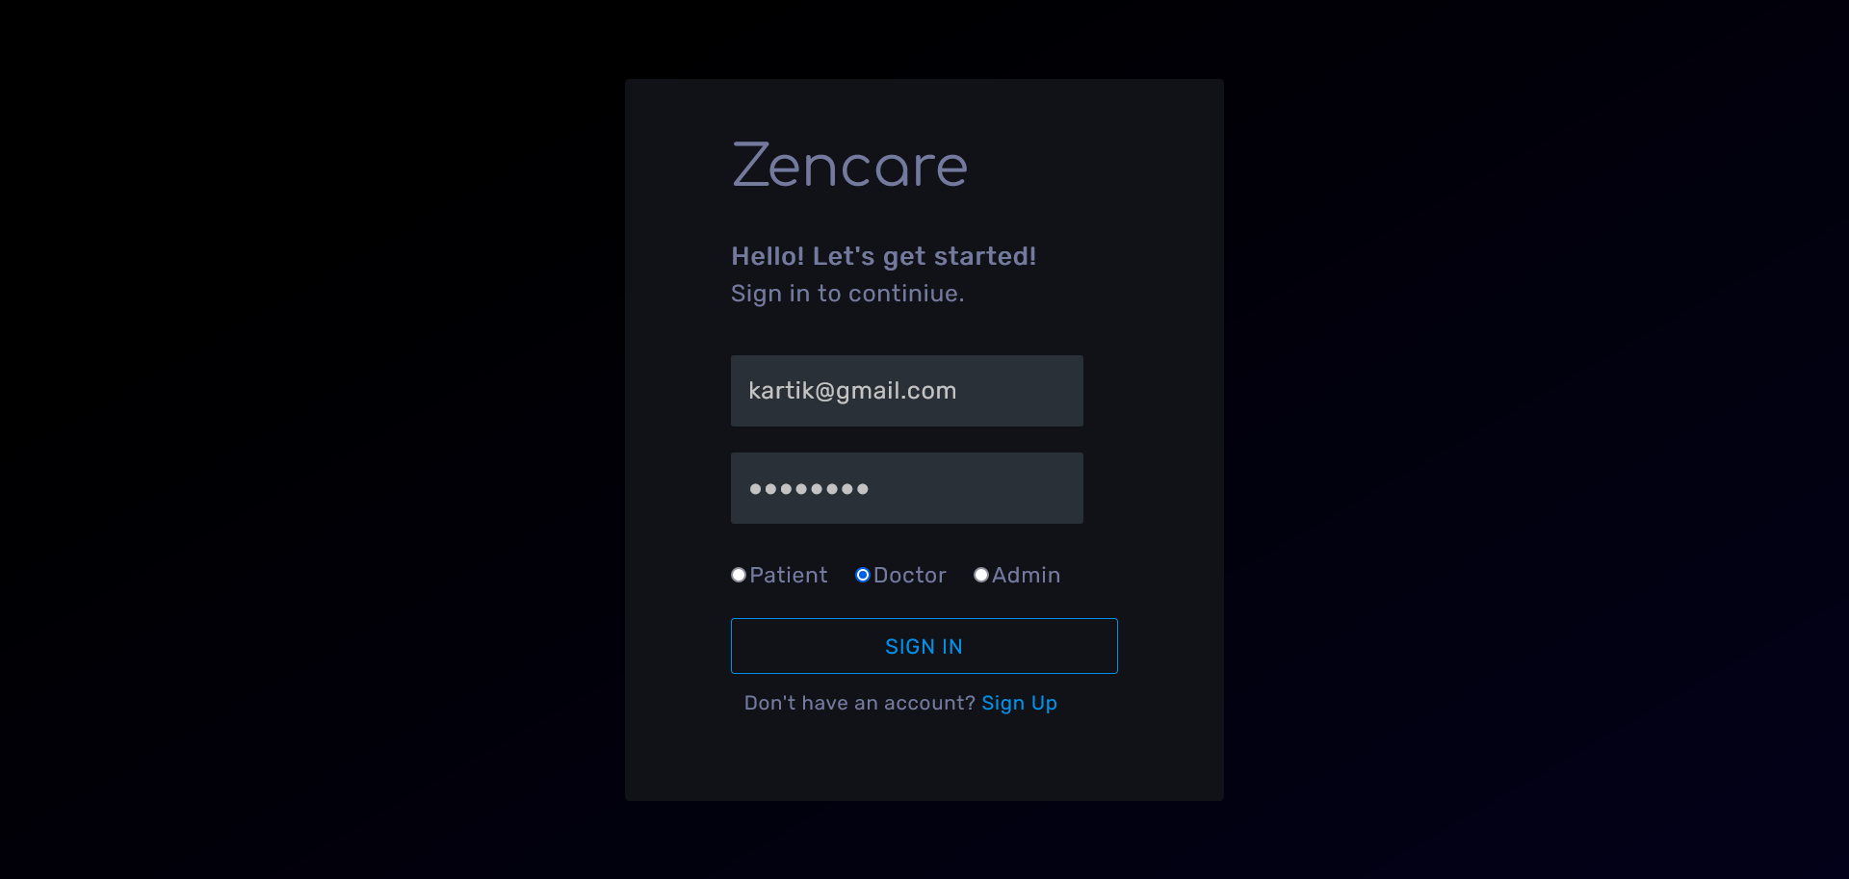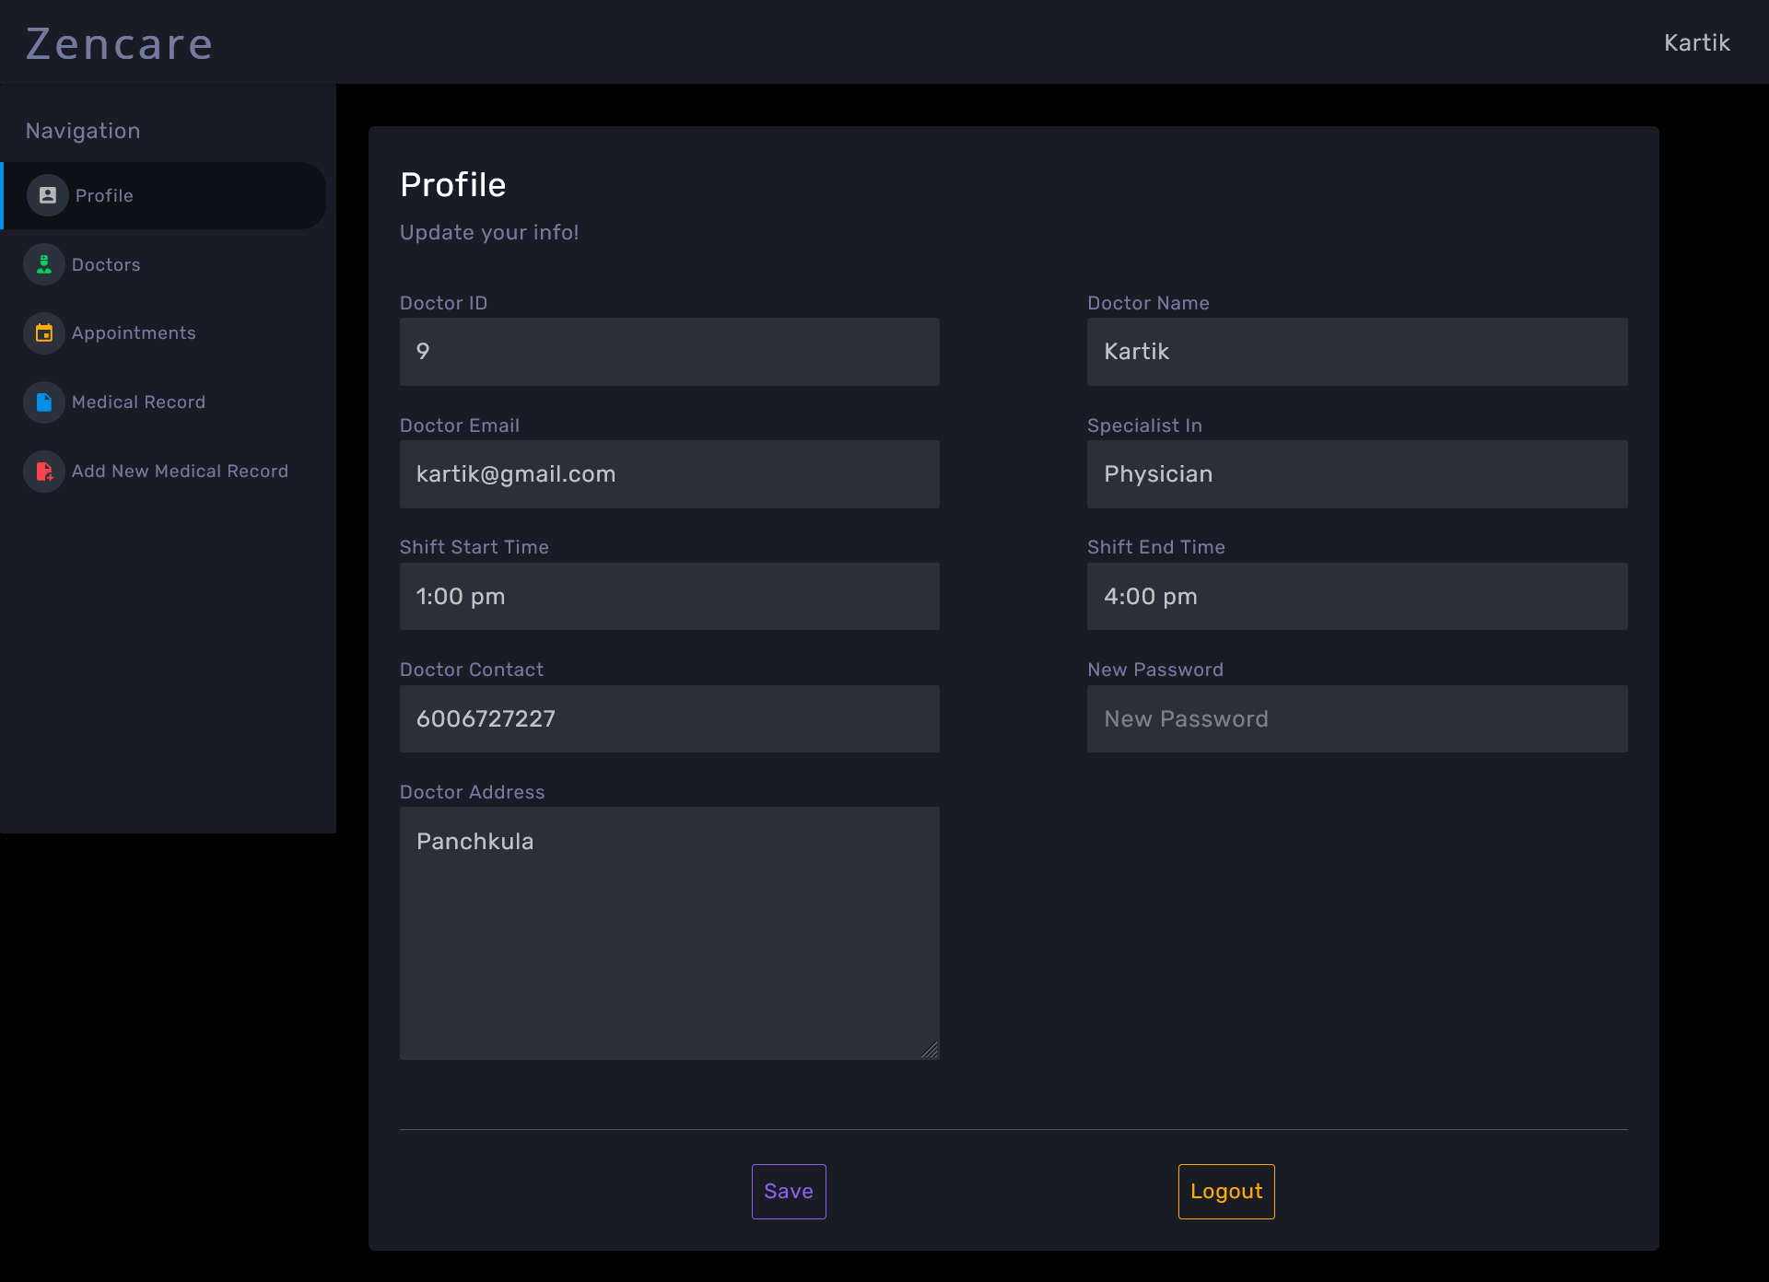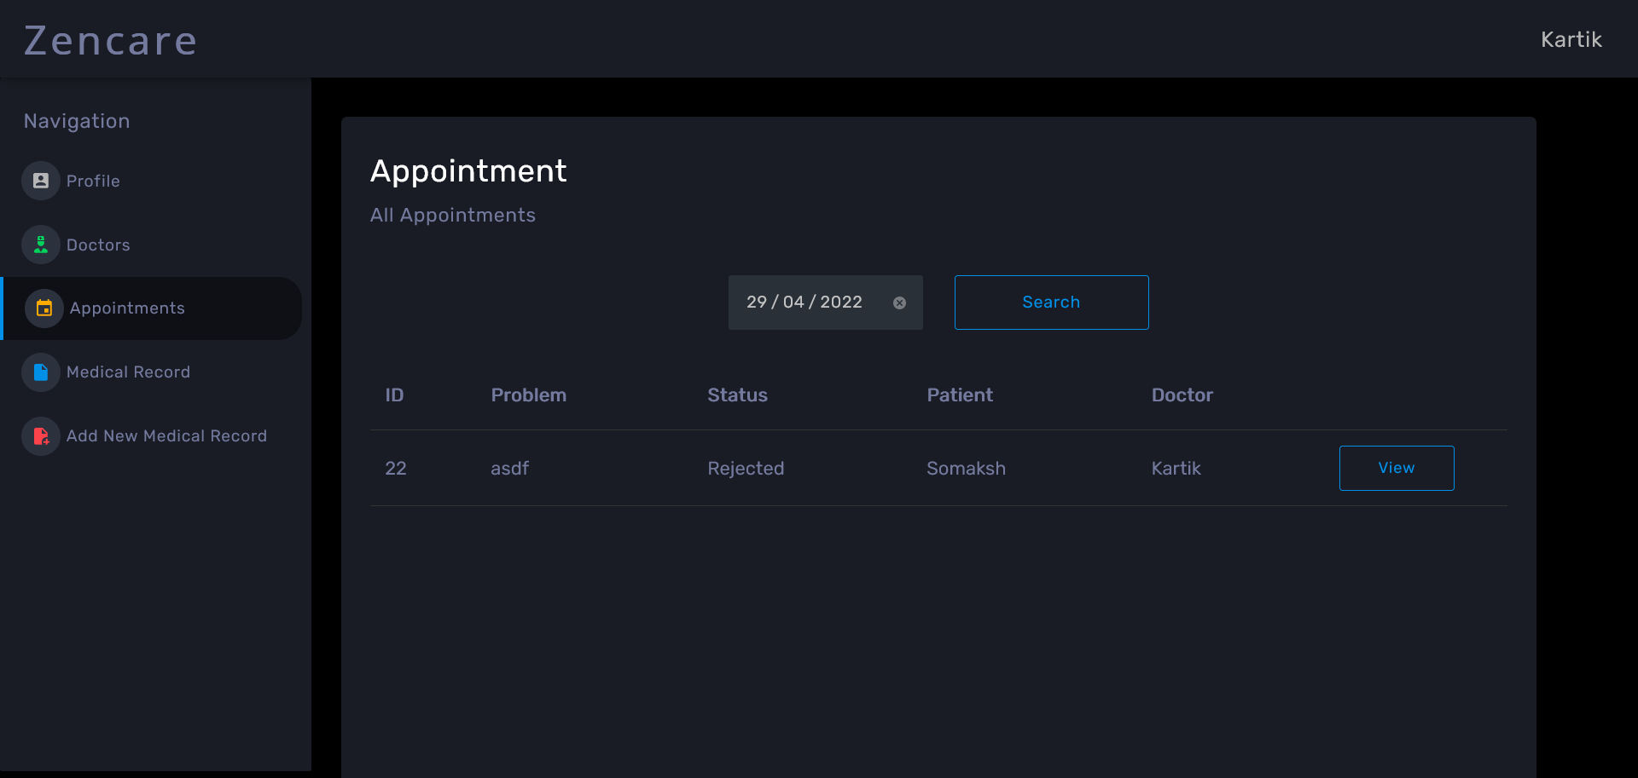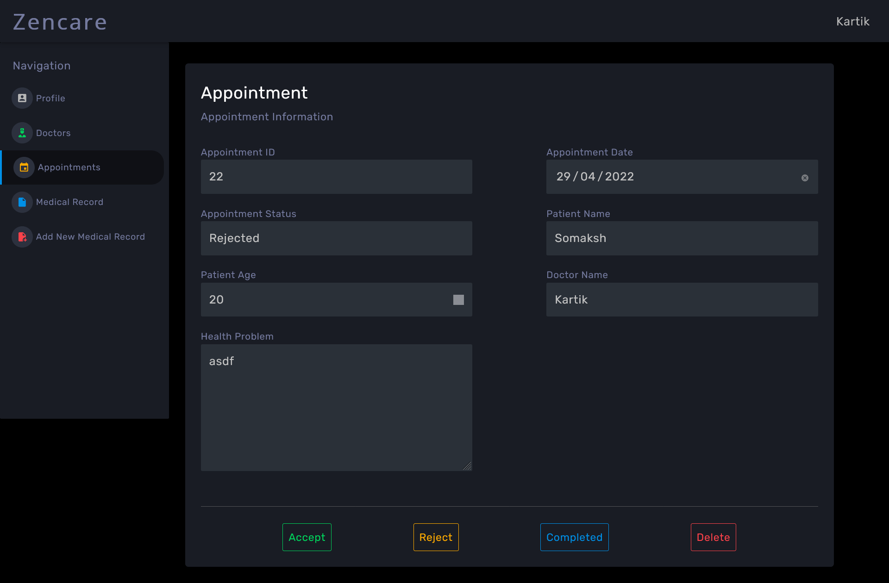

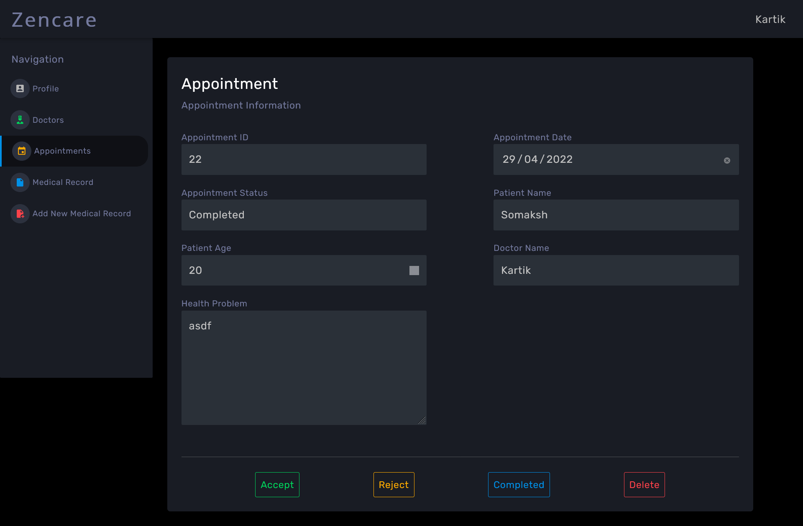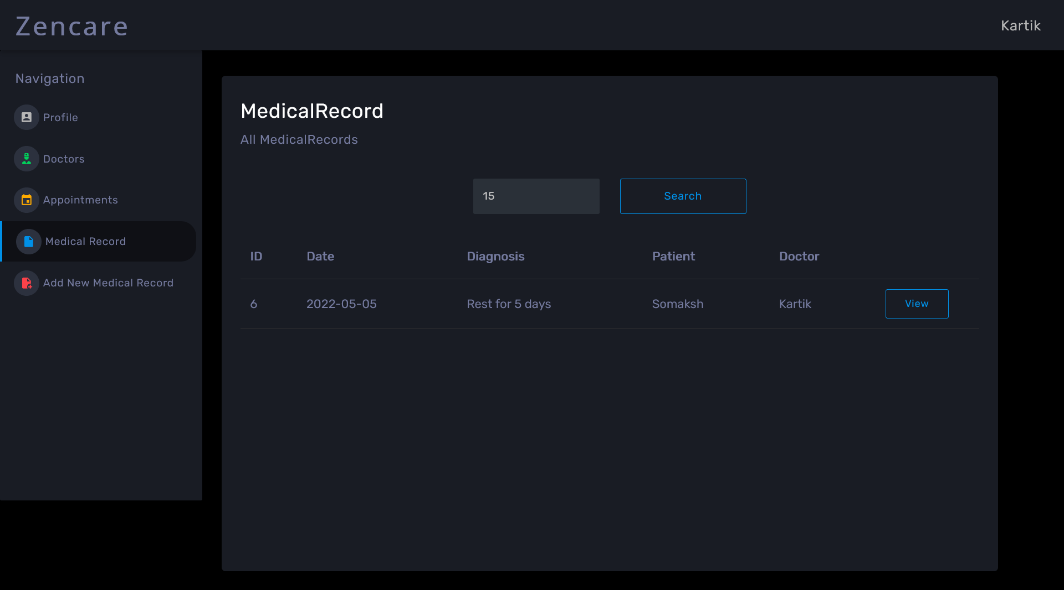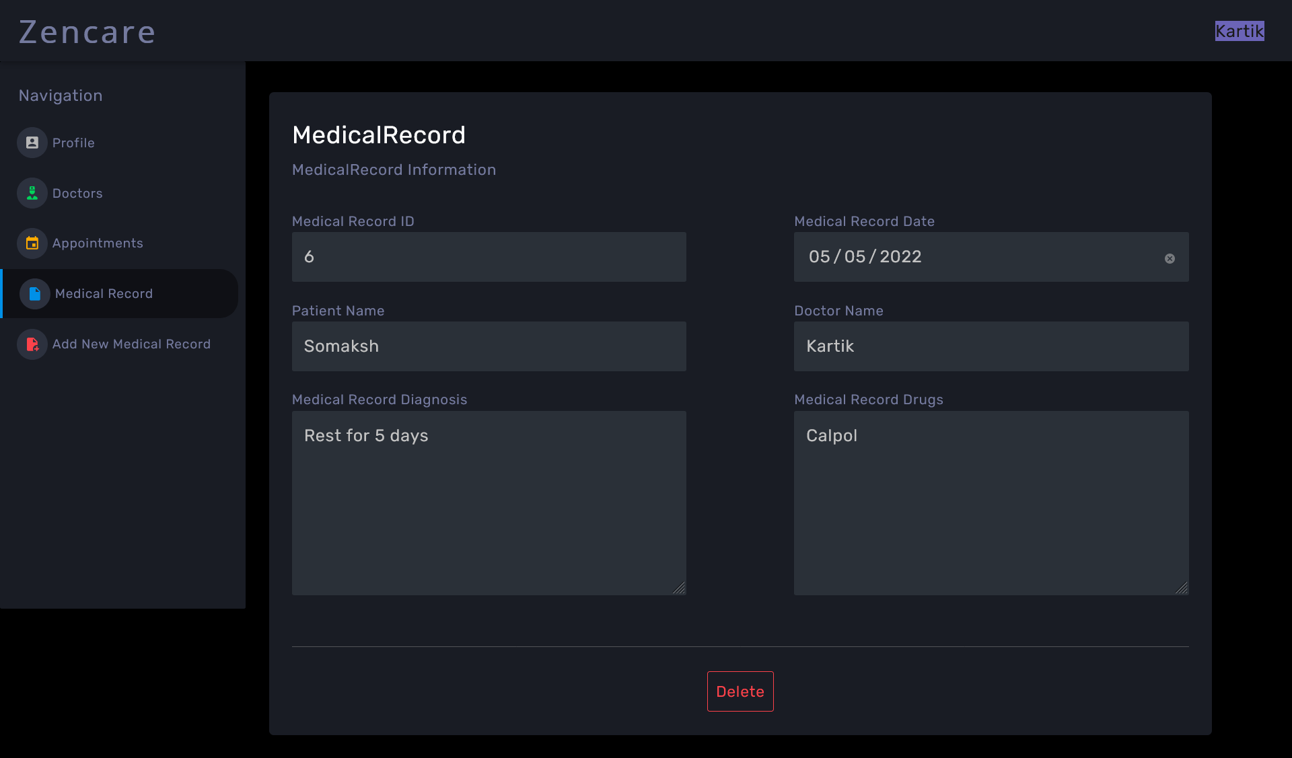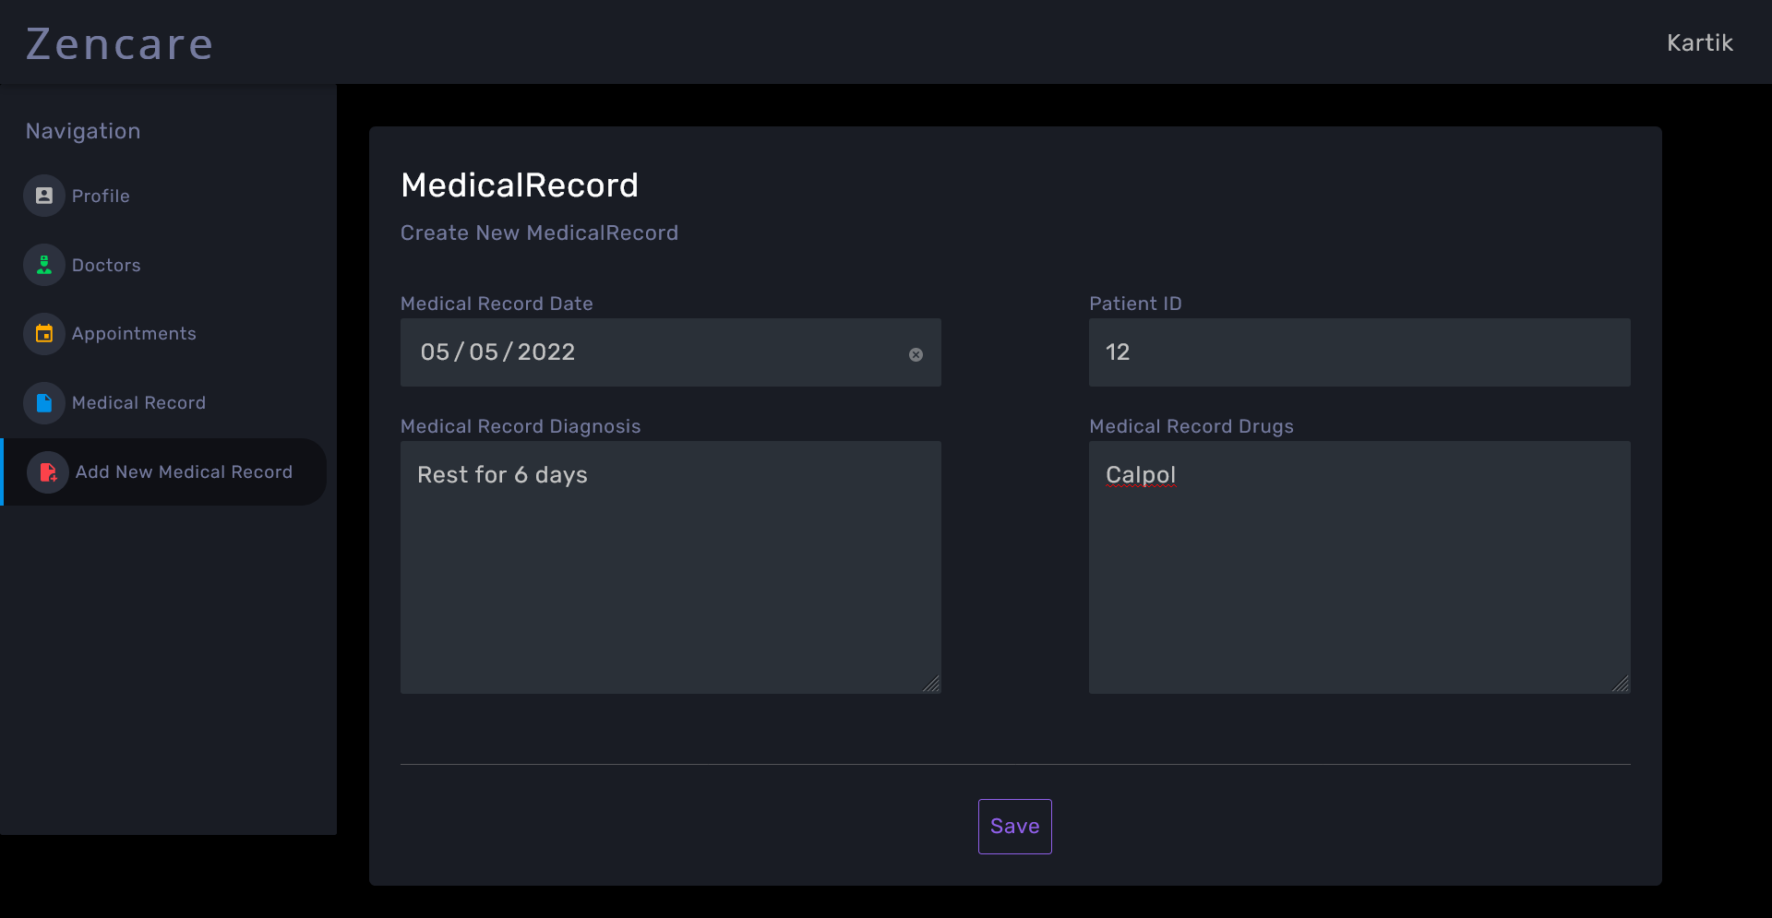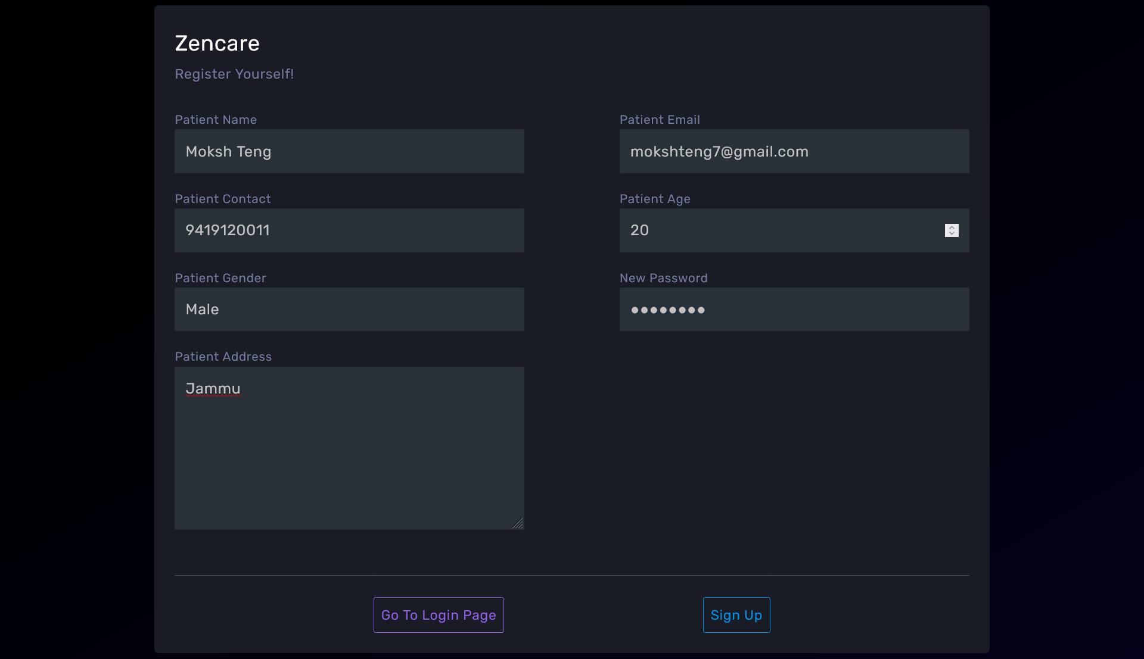

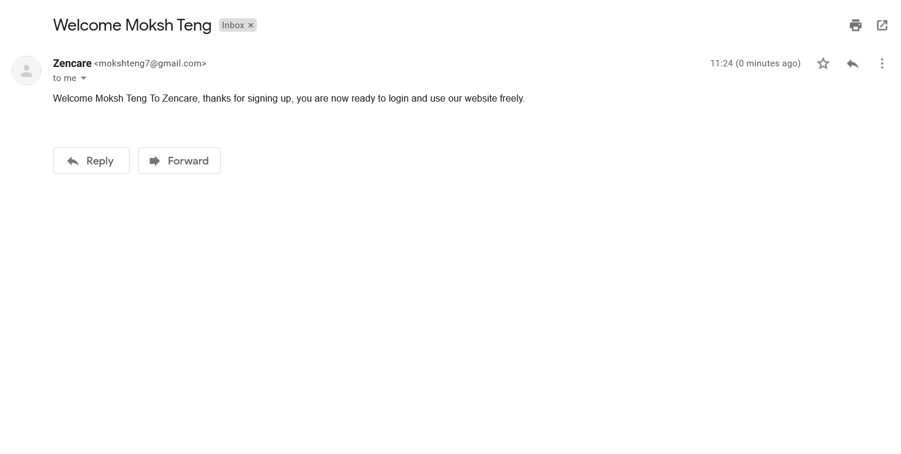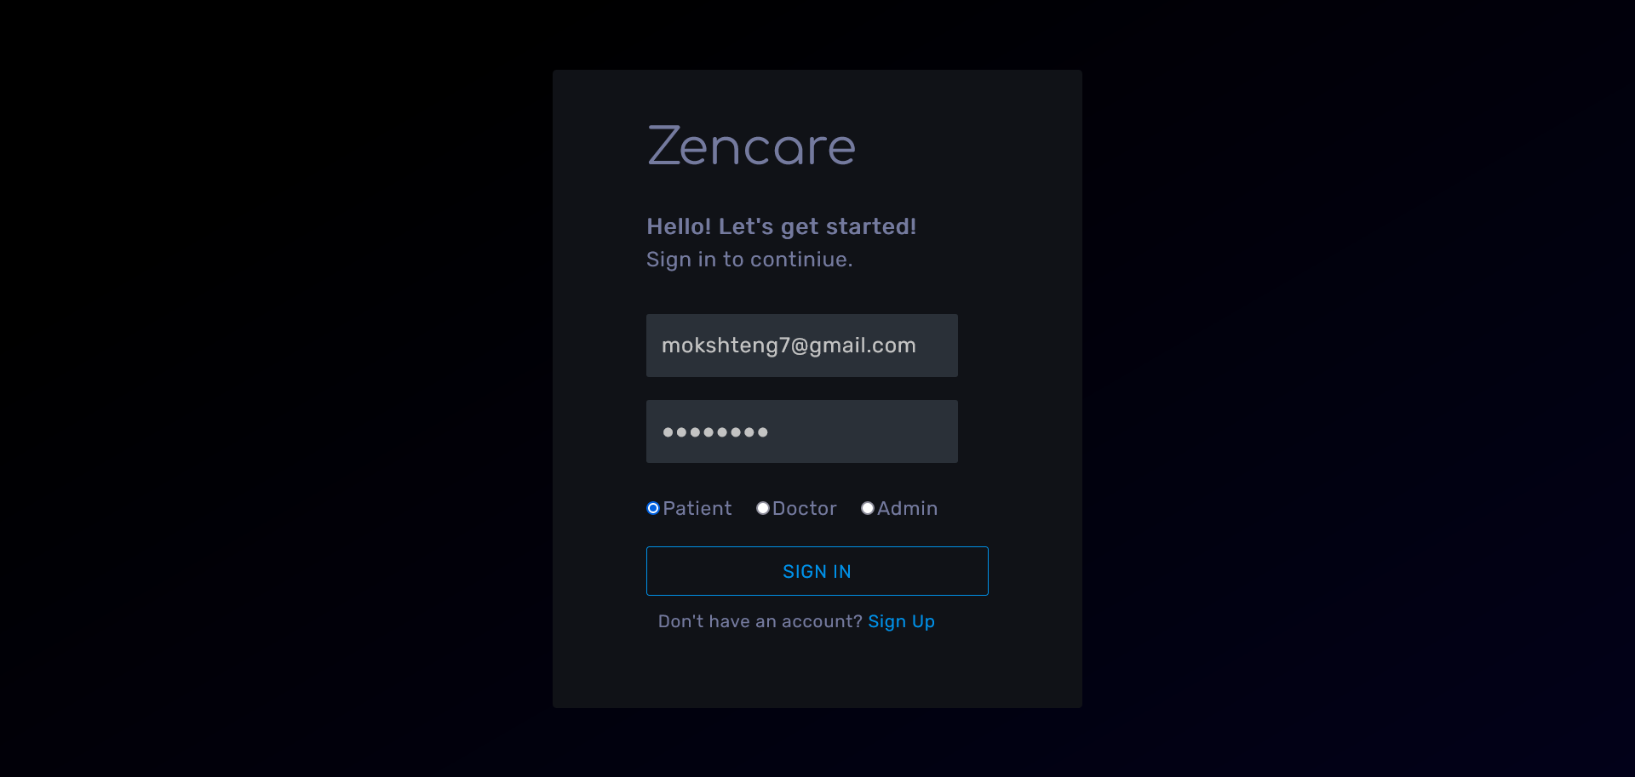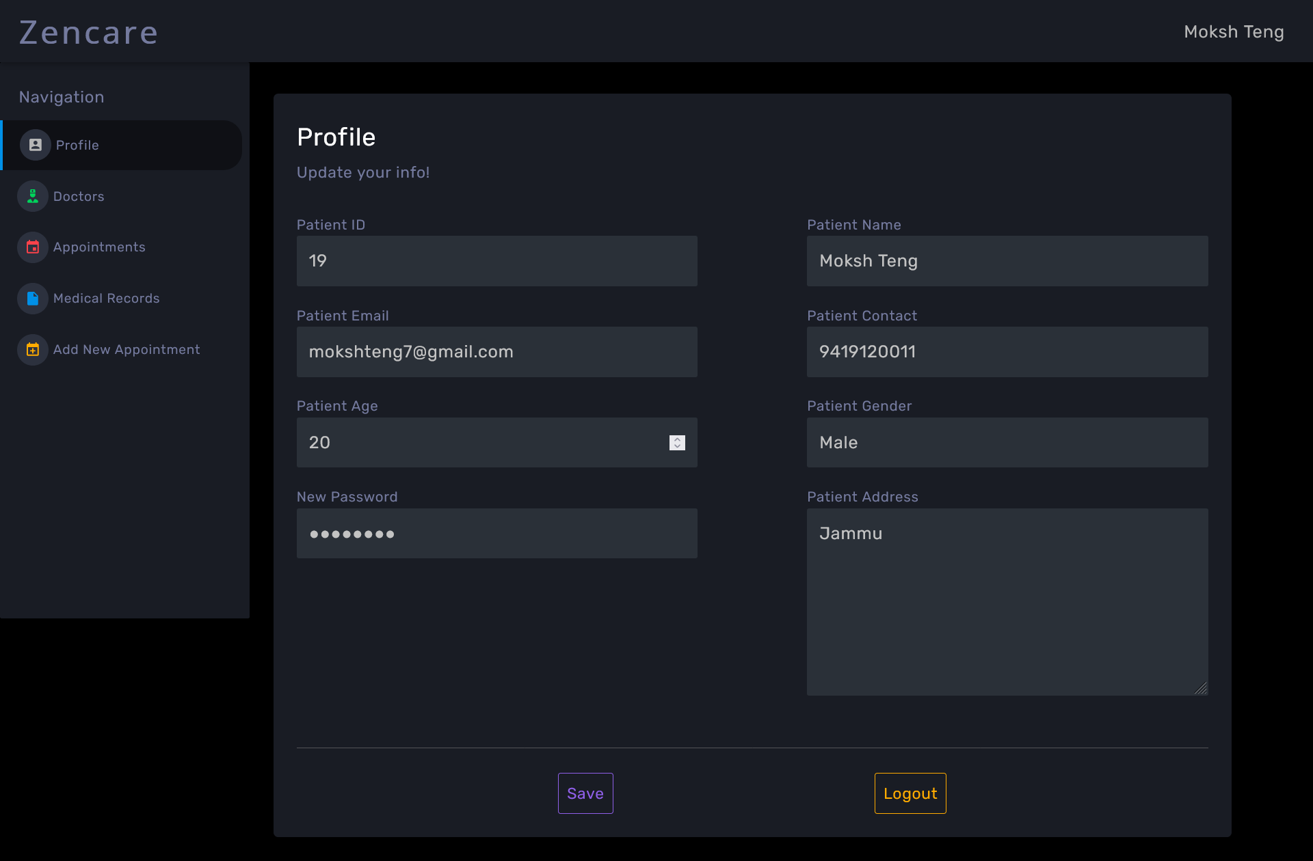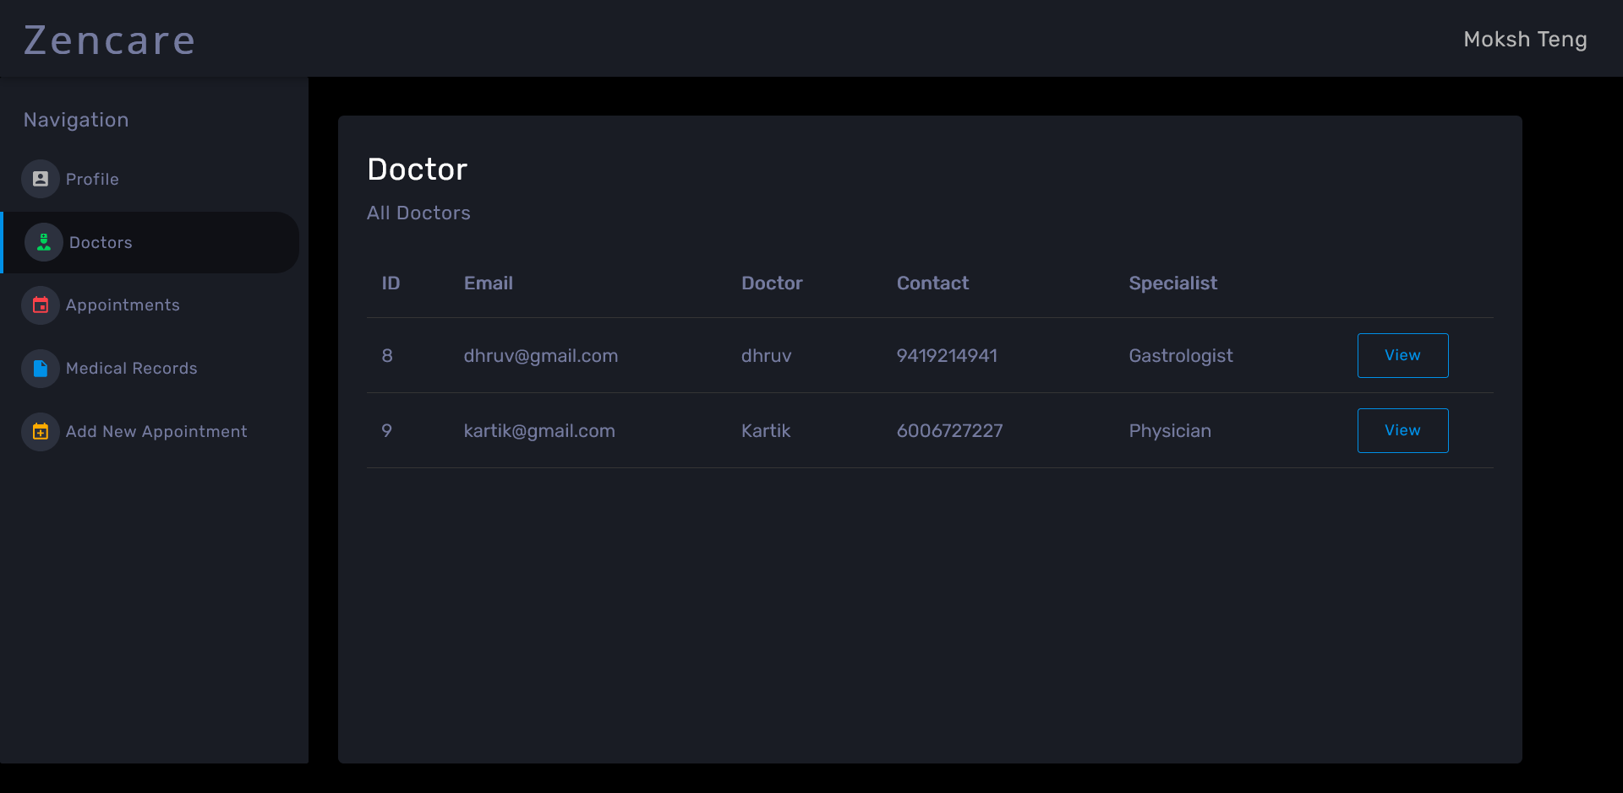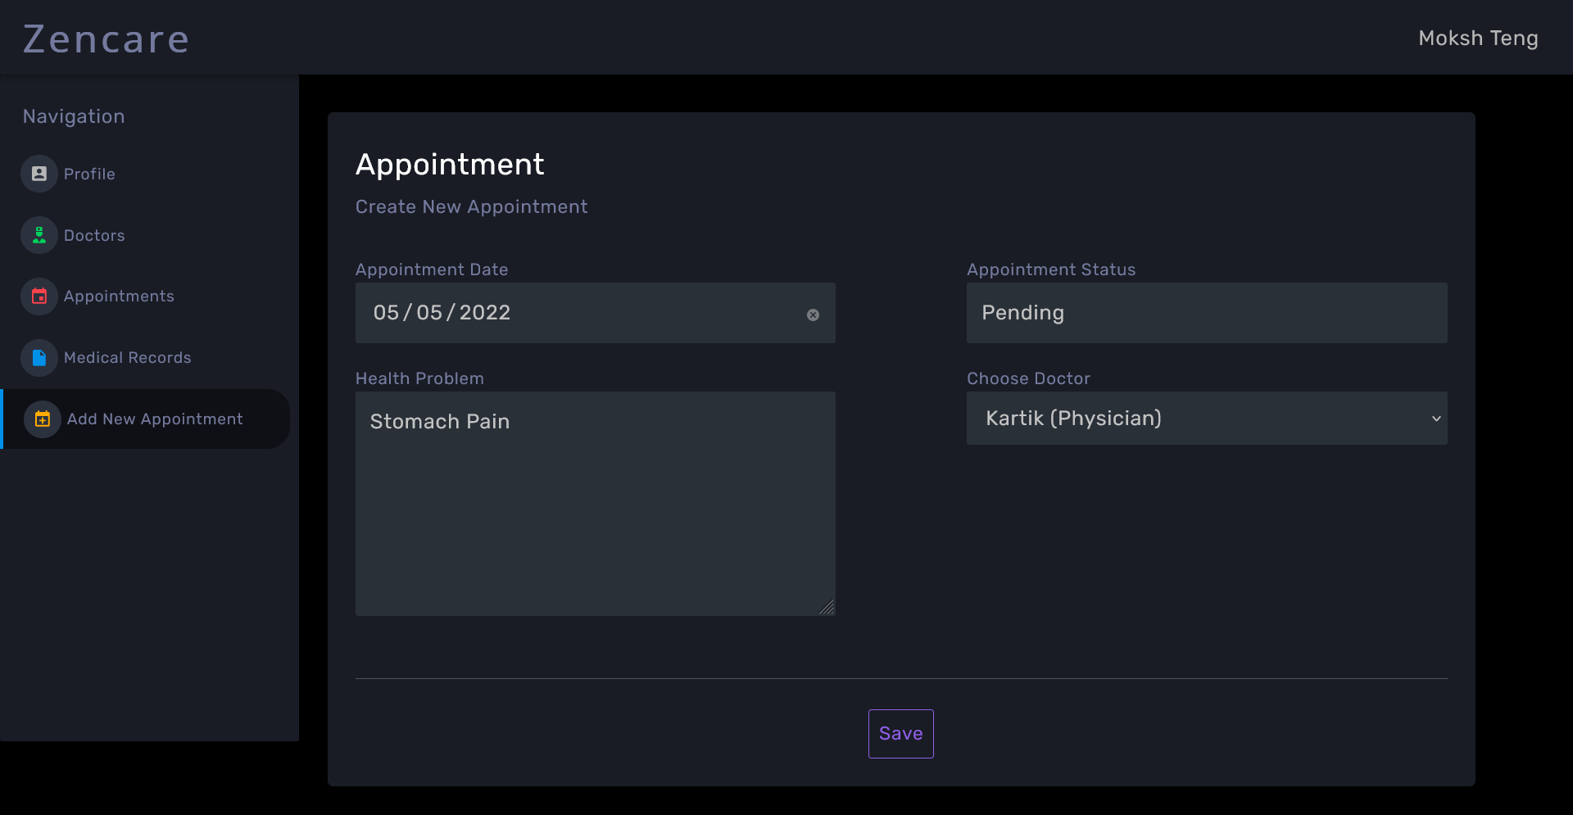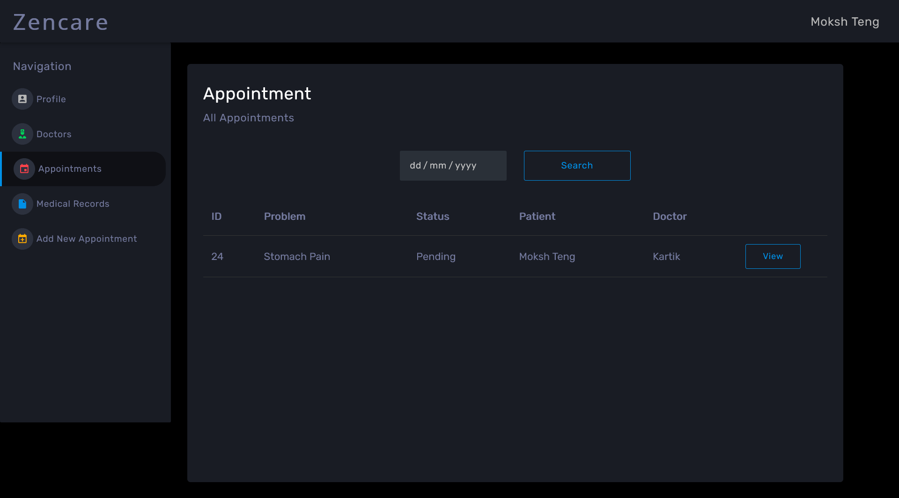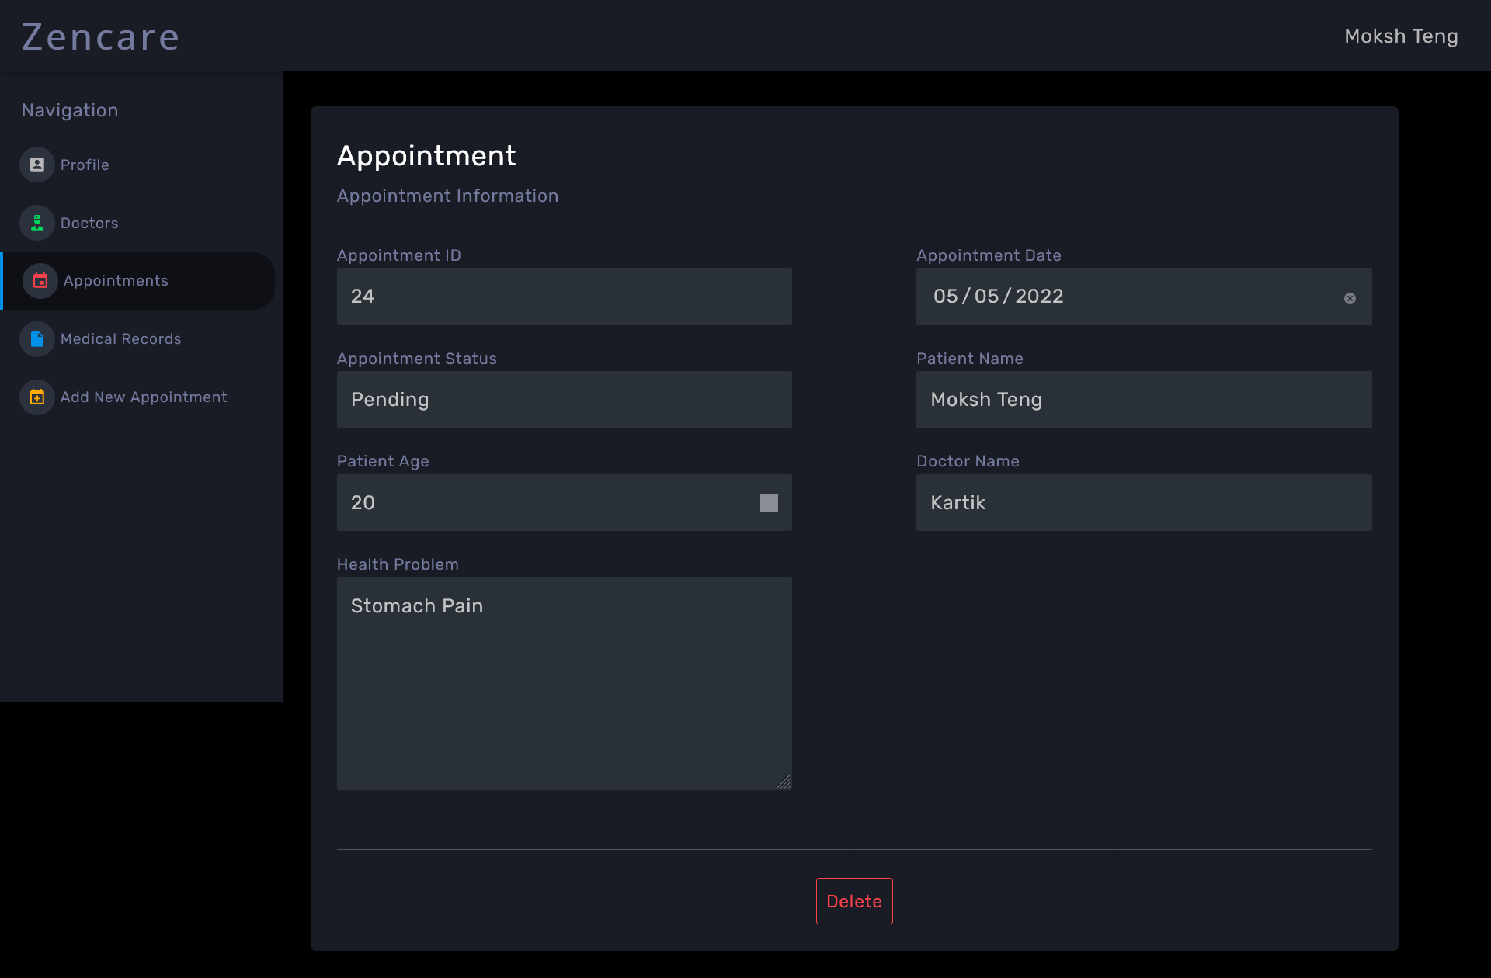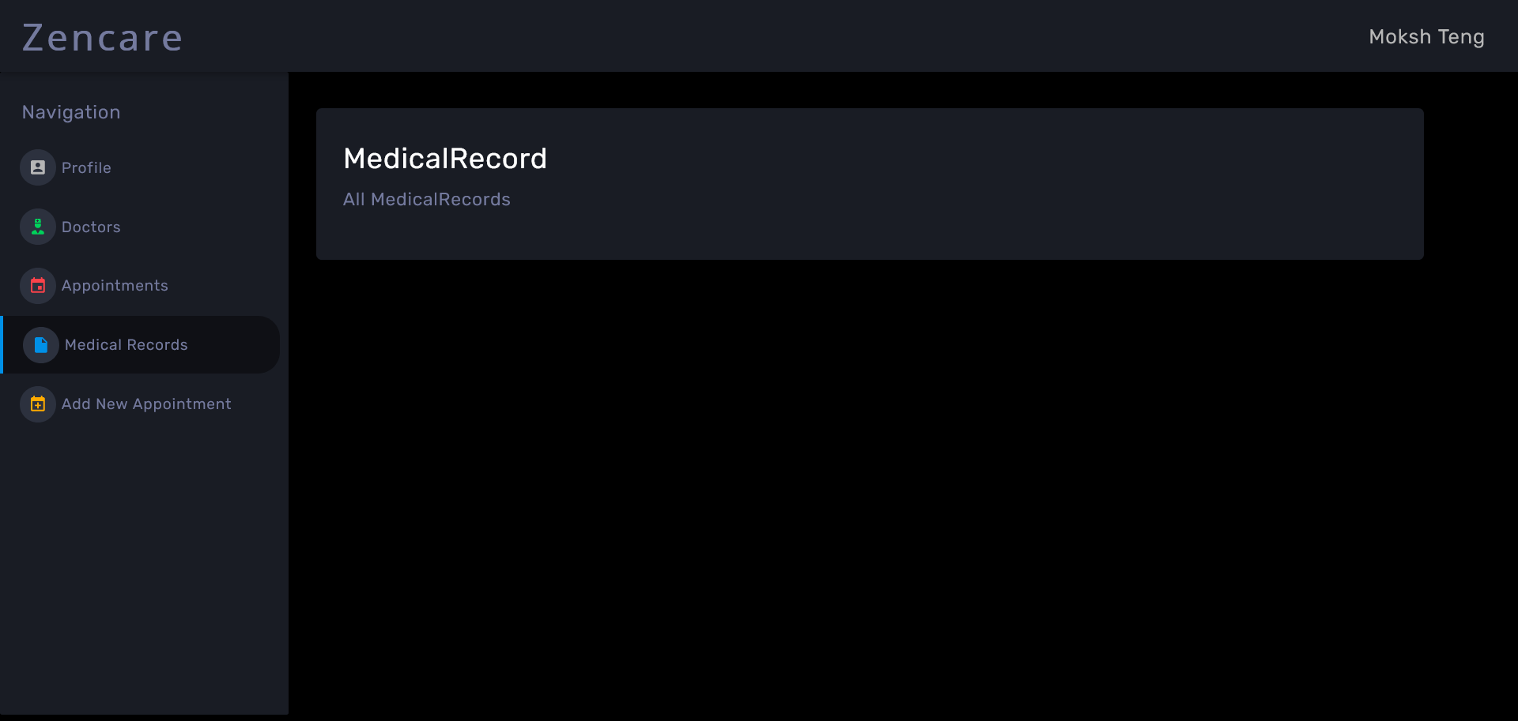

**Future Scope**

The proposed system ‘Health Care’ can be further developed into a separate, automated system with the following enhancements:

* Addition of chat application between doctors and patients.
* Additional security additions like OAuth, email verification on patient signup.
* Forgot password feature.
* Patient Email can be updatable.
* Data visualisation of patient’s medical history.
* Bill Management System.

**Github Links**

Frontend: <https://github.com/moksh10/zencare>

Backend: <https://github.com/moksh10/E-HealthCare-Management-System-Server>